**BACHELOR OF SCIENCE**

**Data Structures & Algorithms**

**Lesson One: Basic Concepts**

This chapter explains the basic terms related to data structure.

**Overview**

Data Structure is a systematic way to organize data in order to use it efficiently. Following terms are the foundation terms of a data structure.

* **Interface** − Each data structure has an interface. Interface represents the set of operations that a data structure supports. An interface only provides the list of supported operations, type of parameters they can accept and return type of these operations.
* **Implementation** − Implementation provides the internal representation of a data structure. Implementation also provides the definition of the algorithms used in the operations of the data structure.

**Characteristics of a Data Structure**

* **Correctness** − Data structure implementation should implement its interface correctly.
* **Time Complexity** − Running time or the execution time of operations of data structure must be as small as possible.
* **Space Complexity** − Memory usage of a data structure operation should be as little as possible.

**Need for Data Structure**

As applications are getting complex and data rich, there are three common problems that applications face now-a-days.

* **Data Search** − Consider an inventory of 1 million(106) items of a store. If the application is to search an item, it has to search an item in 1 million(106) items every time slowing down the search. As data grows, search will become slower.
* **Processor speed** − Processor speed although being very high, falls limited if the data grows to billion records.
* **Multiple requests** − As thousands of users can search data simultaneously on a web server, even the fast server fails while searching the data.

To solve the above-mentioned problems, data structures come to rescue. Data can be organized in a data structure in such a way that all items may not be required to be searched, and the required data can be searched almost instantly.

**Execution Time Cases**

There are three cases which are usually used to compare various data structure's execution time in a relative manner.

* **Worst Case** − This is the scenario where a particular data structure operation takes maximum time it can take. If an operation's worst case time is ƒ(n) then this operation will not take more than ƒ(n) time where ƒ(n) represents function of n.
* **Average Case** − This is the scenario depicting the average execution time of an operation of a data structure. If an operation takes ƒ(n) time in execution, then m operations will take mƒ(n) time.
* **Best Case** − This is the scenario depicting the least possible execution time of an operation of a data structure. If an operation takes ƒ(n) time in execution, then the actual operation may take time as the random number which would be maximum as ƒ(n).

**Basic Terminology**

* **Data** − Data are values or set of values.
* **Data Item** − Data item refers to single unit of values.
* **Group Items** − Data items that are divided into sub items are called as Group Items.
* **Elementary Items** − Data items that cannot be divided are called as Elementary Items.
* **Attribute and Entity** − An entity is that which contains certain attributes or properties, which may be assigned values.
* **Entity Set** − Entities of similar attributes form an entity set.
* **Field** − Field is a single elementary unit of information representing an attribute of an entity.
* **Record** − Record is a collection of field values of a given entity.
* **File** − File is a collection of records of the entities in a given entity set.

**Algorithms Basics**

Algorithm is a step-by-step procedure, which defines a set of instructions to be executed in a certain order to get the desired output. Algorithms are generally created independent of underlying languages, i.e. an algorithm can be implemented in more than one programming language.

From the data structure point of view, following are some important categories of algorithms −

* **Search** − Algorithm to search an item in a data structure.
* **Sort** − Algorithm to sort items in a certain order.
* **Insert** − Algorithm to insert item in a data structure.
* **Update** − Algorithm to update an existing item in a data structure.
* **Delete** − Algorithm to delete an existing item from a data structure.

**Characteristics of an Algorithm**

Not all procedures can be called an algorithm. An algorithm should have the following characteristics −

* **Unambiguous** − Algorithm should be clear and unambiguous. Each of its steps (or phases), and their inputs/outputs should be clear and must lead to only one meaning.
* **Input** − An algorithm should have 0 or more well-defined inputs.
* **Output** − An algorithm should have 1 or more well-defined outputs, and should match the desired output.
* **Finiteness** − Algorithms must terminate after a finite number of steps.
* **Feasibility** − Should be feasible with the available resources.
* **Independent** − An algorithm should have step-by-step directions, which should be independent of any programming code.

**How to Write an Algorithm?**

There are no well-defined standards for writing algorithms. Rather, it is problem and resource dependent. Algorithms are never written to support a particular programming code.

As we know that all programming languages share basic code constructs like loops (do, for, while), flow-control (if-else), etc. These common constructs can be used to write an algorithm.

We write algorithms in a step-by-step manner, but it is not always the case. Algorithm writing is a process and is executed after the problem domain is well-defined. That is, we should know the problem domain, for which we are designing a solution.

**Example**

Let's try to learn algorithm-writing by using an example.

**Problem** − Design an algorithm to add two numbers and display the result.

**step 1** − START

**step 2** − declare three integers **a**, **b** & **c**

**step 3** − define values of **a** & **b**

**step 4** − add values of **a** & **b**

**step 5** − store output of step 4 to **c**

**step 6** − print **c**

**step 7** − STOP

Algorithms tell the programmers how to code the program. Alternatively, the algorithm can be written as −

**step 1** − START ADD

**step 2** − get values of **a** & **b**

**step 3** − c ← a + b

**step 4** − display c

**step 5** − STOP

In design and analysis of algorithms, usually the second method is used to describe an algorithm. It makes it easy for the analyst to analyze the algorithm ignoring all unwanted definitions. He can observe what operations are being used and how the process is flowing.

Writing **step numbers**, is optional.

We design an algorithm to get a solution of a given problem. A problem can be solved in more than one ways.

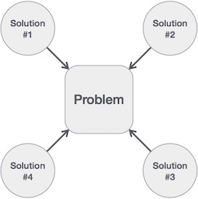

Hence, many solution algorithms can be derived for a given problem. The next step is to analyze those proposed solution algorithms and implement the best suitable solution.

**Algorithm Analysis**

Efficiency of an algorithm can be analyzed at two different stages, before implementation and after implementation. They are the following −

* **A Priori Analysis** − This is a theoretical analysis of an algorithm. Efficiency of an algorithm is measured by assuming that all other factors, for example, processor speed, are constant and have no effect on the implementation.
* **A Posterior Analysis** − This is an empirical analysis of an algorithm. The selected algorithm is implemented using programming language. This is then executed on target computer machine. In this analysis, actual statistics like running time and space required, are collected.

We shall learn about a priori algorithm analysis. Algorithm analysis deals with the execution or running time of various operations involved. The running time of an operation can be defined as the number of computer instructions executed per operation.

**Algorithm Complexity**

Suppose **X** is an algorithm and **n** is the size of input data, the time and space used by the algorithm X are the two main factors, which decide the efficiency of X.

* **Time Factor** − Time is measured by counting the number of key operations such as comparisons in the sorting algorithm.
* **Space Factor** − Space is measured by counting the maximum memory space required by the algorithm.

The complexity of an algorithm **f(n)** gives the running time and/or the storage space required by the algorithm in terms of **n** as the size of input data.

**Space Complexity**

Space complexity of an algorithm represents the amount of memory space required by the algorithm in its life cycle. The space required by an algorithm is equal to the sum of the following two components −

* A fixed part that is a space required to store certain data and variables, that are independent of the size of the problem. For example, simple variables and constants used, program size, etc.
* A variable part is a space required by variables, whose size depends on the size of the problem. For example, dynamic memory allocation, recursion stack space, etc.

Space complexity S(P) of any algorithm P is S(P) = C + SP(I), where C is the fixed part and S(I) is the variable part of the algorithm, which depends on instance characteristic I. Following is a simple example that tries to explain the concept −

Algorithm: SUM(A, B)

Step 1 - START

Step 2 - C ← A + B + 10

Step 3 - Stop

Here we have three variables A, B, and C and one constant. Hence S(P) = 1 + 3. Now, space depends on data types of given variables and constant types and it will be multiplied accordingly.

**Time Complexity**

Time complexity of an algorithm represents the amount of time required by the algorithm to run to completion. Time requirements can be defined as a numerical function T(n), where T(n) can be measured as the number of steps, provided each step consumes constant time.

For example, addition of two n-bit integers takes **n** steps. Consequently, the total computational time is T(n) = c ∗ n, where c is the time taken for the addition of two bits. Here, we observe that T(n) grows linearly as the input size increases.

**Data Structures - Asymptotic Analysis**

Asymptotic analysis of an algorithm refers to defining the mathematical boundation/framing of its run-time performance. Using asymptotic analysis, we can very well conclude the best case, average case, and worst case scenario of an algorithm.

Asymptotic analysis is input bound i.e., if there's no input to the algorithm, it is concluded to work in a constant time. Other than the "input" all other factors are considered constant.

Asymptotic analysis refers to computing the running time of any operation in mathematical units of computation. For example, the running time of one operation is computed as *f*(n) and may be for another operation it is computed as *g*(n2). This means the first operation running time will increase linearly with the increase in **n** and the running time of the second operation will increase exponentially when **n** increases. Similarly, the running time of both operations will be nearly the same if **n** is significantly small.

Usually, the time required by an algorithm falls under three types −

* **Best Case** − Minimum time required for program execution.
* **Average Case** − Average time required for program execution.
* **Worst Case** − Maximum time required for program execution.

**Asymptotic Notations**

Following are the commonly used asymptotic notations to calculate the running time complexity of an algorithm.

* Ο Notation
* Ω Notation
* θ Notation

**Big Oh Notation, Ο**

The notation Ο(n) is the formal way to express the upper bound of an algorithm's running time. It measures the worst case time complexity or the longest amount of time an algorithm can possibly take to complete.

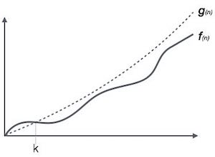

For example, for a function ***f*(n)**

Ο(*f*(n)) = { *g*(n) : there exists c > 0 and n0 such that *f*(n) ≤ c.*g*(n) for all n > n0. }

**Omega Notation, Ω**

The notation Ω(n) is the formal way to express the lower bound of an algorithm's running time. It measures the best case time complexity or the best amount of time an algorithm can possibly take to complete.

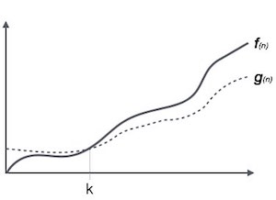

For example, for a function ***f*(n)**

Ω(*f*(n)) ≥ { *g*(n) : there exists c > 0 and n0 such that *g*(n) ≤ c.*f*(n) for all n > n0. }

**Theta Notation, θ**

The notation θ(n) is the formal way to express both the lower bound and the upper bound of an algorithm's running time. It is represented as follows −

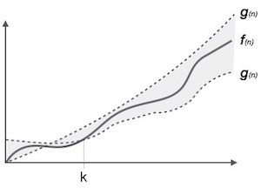

θ(*f*(n)) = { *g*(n) if and only if *g*(n) = Ο(*f*(n)) and *g*(n) = Ω(*f*(n)) for all n > n0. }

**Common Asymptotic Notations**

Following is a list of some common asymptotic notations −

|  |  |  |
| --- | --- | --- |
| constant | − | Ο(1) |
| logarithmic | − | Ο(log n) |
| linear | − | Ο(n) |
| n log n | − | Ο(n log n) |
| quadratic | − | Ο(n2) |
| cubic | − | Ο(n3) |
| polynomial | − | nΟ(1) |
| exponential | − | 2Ο(n) |

**Data Definition**

Data Definition defines a particular data with the following characteristics.

* **Atomic** − Definition should define a single concept.
* **Traceable** − Definition should be able to be mapped to some data element.
* **Accurate** − Definition should be unambiguous.
* **Clear and Concise** − Definition should be understandable.

**Data Object**

Data Object represents an object having a data.

**Data Type**

Data type is a way to classify various types of data such as integer, string, etc. which determines the values that can be used with the corresponding type of data, the type of operations that can be performed on the corresponding type of data. There are two data types −

* Built-in Data Type
* Derived Data Type

**Built-in Data Type**

Those data types for which a language has built-in support are known as Built-in Data types. For example, most of the languages provide the following built-in data types.

* Integers
* Boolean (true, false)
* Floating (Decimal numbers)
* Character and Strings

**Derived Data Type**

Those data types which are implementation independent as they can be implemented in one or the other way are known as derived data types. These data types are normally built by the combination of primary or built-in data types and associated operations on them. For example −

* List
* Array
* Stack
* Queue

**Basic Operations**

The data in the data structures are processed by certain operations. The particular data structure chosen largely depends on the frequency of the operation that needs to be performed on the data structure.

* Traversing
* Searching
* Insertion
* Deletion
* Sorting
* Merging

**Lesson Two: Arrays**

Array is a container which can hold a fix number of items and these items should be of the same type. Most of the data structures make use of arrays to implement their algorithms. Following are the important terms to understand the concept of Array.

* **Element** − Each item stored in an array is called an element.
* **Index** − Each location of an element in an array has a numerical index, which is used to identify the element.

**Array Representation**

Arrays can be declared in various ways in different languages. For illustration, let's take C array declaration.

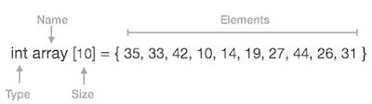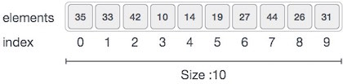

As per the above illustration, following are the important points to be considered.

* Index starts with 0.
* Array length is 10 which means it can store 10 elements.
* Each element can be accessed via its index. For example, we can fetch an element at index 6 as 9.

**Basic Operations**

Following are the basic operations supported by an array.

* **Traverse** − print all the array elements one by one.
* **Insertion** − Adds an element at the given index.
* **Deletion** − Deletes an element at the given index.
* **Search** − Searches an element using the given index or by the value.
* **Update** − Updates an element at the given index.

In C, when an array is initialized with size, then it assigns defaults values to its elements in following order.

|  |  |
| --- | --- |
| **Data Type** | **Default Value** |
| Bool | False |
| Char | 0 |
| Int | 0 |
| Float | 0.0 |
| Double | 0.0f |
| Void |  |
| wchar_t | 0 |

**Insertion Operation**

Insert operation is to insert one or more data elements into an array. Based on the requirement, a new element can be added at the beginning, end, or any given index of array.

Here, we see a practical implementation of insertion operation, where we add data at the end of the array −

**Algorithm**

Let **Array** be a linear unordered array of **MAX** elements.

**Example**

**Result**

Let **LA** be a Linear Array (unordered) with **N** elements and **K** is a positive integer such that **K<=N**. Following is the algorithm where ITEM is inserted into the Kth position of LA −

1. Start

2. Set J = N

3. Set N = N+1

4. Repeat steps 5 and 6 while J >= K

5. Set LA[J+1] = LA[J]

6. Set J = J-1

7. Set LA[K] = ITEM

8. Stop

**Example**

Following is the implementation of the above algorithm −

#include <stdio.h>

main() {

int LA[] = {1,3,5,7,8};

int item = 10, k = 3, n = 5;

int i = 0, j = n;

printf("The original array elements are :\n");

for(i = 0; i<n; i++) {

printf("LA[%d] = %d \n", i, LA[i]);

}

n = n + 1;

while( j >= k) {

LA[j+1] = LA[j];

j = j - 1;

}

LA[k] = item;

printf("The array elements after insertion :\n");

for(i = 0; i<n; i++) {

printf("LA[%d] = %d \n", i, LA[i]);

}

}

When we compile and execute the above program, it produces the following result −

**Output**

The original array elements are :

LA[0] = 1

LA[1] = 3

LA[2] = 5

LA[3] = 7

LA[4] = 8

The array elements after insertion :

LA[0] = 1

LA[1] = 3

LA[2] = 5

LA[3] = 10

LA[4] = 7

LA[5] = 8

For other variations of array insertion operation see section below:

In the previous section, we have learnt how the insertion operation works. It is not always necessary that an element is inserted at the end of an array. Following can be a situation with array insertion −

* Insertion at the beginning of an array
* Insertion at the given index of an array
* Insertion after the given index of an array
* Insertion before the given index of an array

Insertion at the Beginning of an Array

When the insertion happens at the beginning, it causes all the existing data items to shift one step downward. Here, we design and implement an algorithm to insert an element at the beginning of an array.

Algorithm

We assume **A** is an array with **N** elements. The maximum numbers of elements it can store is defined by **MAX**. We shall first check if an array has any empty space to store any element and then we proceed with the insertion process.

begin

IF N = MAX, return

ELSE

N = N + 1

For All Elements in A

Move to next adjacent location

A[FIRST] = New_Element

end

Implementation in C

#include <stdio.h>

#define MAX 5

void main() {

int array[MAX] = {2, 3, 4, 5};

int N = 4; // number of elements in array

int i = 0; // loop variable

int value = 1; // new data element to be stored in array

// print array before insertion

printf("Printing array before insertion −\n");

for(i = 0; i < N; i++) {

printf("array[%d] = %d \n", i, array[i]);

}

// now shift rest of the elements downwards

for(i = N; i >= 0; i--) {

array[i+1] = array[i];

}

// add new element at first position

array[0] = value;

// increase N to reflect number of elements

N++;

// print to confirm

printf("Printing array after insertion −\n");

for(i = 0; i < N; i++) {

printf("array[%d] = %d\n", i, array[i]);

}

}

This program should yield the following output −

Output

Printing array before insertion −

array[0] = 2

array[1] = 3

array[2] = 4

array[3] = 5

Printing array after insertion −

array[0] = 0

array[1] = 2

array[2] = 3

array[3] = 4

array[4] = 5

Insertion at the Given Index of an Array

In this scenario, we are given the exact location (**index**) of an array where a new data element (**value**) needs to be inserted. First we shall check if the array is full, if it is not, then we shall move all data elements from that location one step downward. This will make room for a new data element.

Algorithm

We assume **A** is an array with **N** elements. The maximum numbers of elements it can store is defined by **MAX**.

begin

IF N = MAX, return

ELSE

N = N + 1

SEEK Location index

For All Elements from A[index] to A[N]

Move to next adjacent location

A[index] = New_Element

end

Implementation in C

#include <stdio.h>

#define MAX 5

void main() {

int array[MAX] = {1, 2, 4, 5};

int N = 4; // number of elements in array

int i = 0; // loop variable

int index = 2; // index location to insert new value

int value = 3; // new data element to be inserted

// print array before insertion

printf("Printing array before insertion −\n");

for(i = 0; i < N; i++) {

printf("array[%d] = %d \n", i, array[i]);

}

// now shift rest of the elements downwards

for(i = N; i >= index; i--) {

array[i+1] = array[i];

}

// add new element at first position

array[index] = value;

// increase N to reflect number of elements

N++;

// print to confirm

printf("Printing array after insertion −\n");

for(i = 0; i < N; i++) {

printf("array[%d] = %d\n", i, array[i]);

}

}

If we compile and run the above program, it will produce the following result −

Output

Printing array before insertion −

array[0] = 1

array[1] = 2

array[2] = 4

array[3] = 5

Printing array after insertion −

array[0] = 1

array[1] = 2

array[2] = 3

array[3] = 4

array[4] = 5

Insertion After the Given Index of an Array

In this scenario we are given a location (**index**) of an array after which a new data element (**value**) has to be inserted. Only the seek process varies, the rest of the activities are the same as in the previous example.

Algorithm

We assume **A** is an array with **N** elements. The maximum numbers of elements it can store is defined by **MAX**.

begin

IF N = MAX, return

ELSE

N = N + 1

SEEK Location index

For All Elements from A[index + 1] to A[N]

Move to next adjacent location

A[index + 1] = New_Element

end

Implementation in C

#include <stdio.h>

#define MAX 5

void main() {

int array[MAX] = {1, 2, 4, 5};

int N = 4; // number of elements in array

int i = 0; // loop variable

int index = 1; // index location after which **value** will be inserted

int value = 3; // new data element to be inserted

// print array before insertion

printf("Printing array before insertion −\n");

for(i = 0; i < N; i++) {

printf("array[%d] = %d \n", i, array[i]);

}

// now shift rest of the elements downwards

for(i = N; i >= index + 1; i--) {

array[i + 1] = array[i];

}

// add new element at first position

array[index + 1] = value;

// increase N to reflect number of elements

N++;

// print to confirm

printf("Printing array after insertion −\n");

for(i = 0; i < N; i++) {

printf("array[%d] = %d\n", i, array[i]);

}

}

If we compile and run the above program, it will produce the following result −

Output

Printing array before insertion −

array[0] = 1

array[1] = 2

array[2] = 4

array[3] = 5

Printing array after insertion −

array[0] = 1

array[1] = 2

array[2] = 3

array[3] = 4

array[4] = 5

Insertion Before the Given Index of an Array

In this scenario we are given a location (**index**) of an array before which a new data element (**value**) has to be inserted. This time we seek till **index-1** i.e., one location ahead of given index, rest of the activities are same as in previous example.

Algorithm

We assume **A** is an array with **N** elements. The maximum numbers of elements it can store is defined by **MAX**.

begin

IF N = MAX, return

ELSE

N = N + 1

SEEK Location index

For All Elements from A[index - 1] to A[N]

Move to next adjacent location

A[index - 1] = New_Element

end

Implementation in C

#include <stdio.h>

#define MAX 5

void main() {

int array[MAX] = {1, 2, 4, 5};

int N = 4; // number of elements in array

int i = 0; // loop variable

int index = 3; // index location before which **value** will be inserted

int value = 3; // new data element to be inserted

// print array before insertion

printf("Printing array before insertion −\n");

for(i = 0; i < N; i++) {

printf("array[%d] = %d \n", i, array[i]);

}

// now shift rest of the elements downwards

for(i = N; i >= index + 1; i--) {

array[i + 1] = array[i];

}

// add new element at first position

array[index + 1] = value;

+

// increase N to reflect number of elements

N++;

// print to confirm

printf("Printing array after insertion −\n");

for(i = 0; i < N; i++) {

printf("array[%d] = %d\n", i, array[i]);

}

}

If we compile and run the above program, it will produce the following result −

Output

Printing array before insertion −

array[0] = 1

array[1] = 2

array[2] = 4

array[3] = 5

Printing array after insertion −

array[0] = 1

array[1] = 2

array[2] = 4

array[3] = 5

array[4] = 3

**Deletion Operation**

Deletion refers to removing an existing element from the array and re-organizing all elements of an array.

**Algorithm**

Consider **LA** is a linear array with **N** elements and **K** is a positive integer such that **K<=N**. Following is the algorithm to delete an element available at the Kth position of LA.

1. Start

2. Set J = K

3. Repeat steps 4 and 5 while J < N

4. Set LA[J-1] = LA[J]

5. Set J = J+1

6. Set N = N-1

7. Stop

**Example**

Following is the implementation of the above algorithm −

#include <stdio.h>

main() {

int LA[] = {1,3,5,7,8};

int k = 3, n = 5;

int i, j;

printf("The original array elements are :\n");

for(i = 0; i<n; i++) {

printf("LA[%d] = %d \n", i, LA[i]);

}

j = k;

while( j < n) {

LA[j-1] = LA[j];

j = j + 1;

}

n = n -1;

printf("The array elements after deletion :\n");

for(i = 0; i<n; i++) {

printf("LA[%d] = %d \n", i, LA[i]);

}

}

When we compile and execute the above program, it produces the following result −

**Output**

The original array elements are :

LA[0] = 1

LA[1] = 3

LA[2] = 5

2LA[3] = 7

LA[4] = 8

The array elements after deletion :

LA[0] = 1

LA[1] = 3

LA[2] = 7

LA[3] = 8

**Search Operation**

You can perform a search for an array element based on its value or its index.

**Algorithm**

Consider **LA** is a linear array with **N** elements and **K** is a positive integer such that **K<=N**. Following is the algorithm to find an element with a value of ITEM using sequential search.

1. Start

2. Set J = 0

3. Repeat steps 4 and 5 while J < N

4. IF LA[J] is equal ITEM THEN GOTO STEP 6

5. Set J = J +1

6. PRINT J, ITEM

7. Stop

**Example**

Following is the implementation of the above algorithm −

**#include <stdio.h>**

**main() {**

**int LA[] = {1,3,5,7,8};**

**int item = 5, n = 5;**

**int i = 0, j = 0;**

**printf("The original array elements are :\n");**

**for(i = 0; i<n; i++) {**

**printf("LA[%d] = %d \n", i, LA[i]);**

**}**

**while( j < n){**

**if( LA[j] == item ) {**

**break;**

**}**

**j = j + 1;**

**}**

**printf("Found element %d at position %d\n", item, j+1);**

**}**

When we compile and execute the above program, it produces the following result −

**Output**

The original array elements are :

LA[0] = 1

LA[1] = 3

LA[2] = 5

LA[3] = 7

LA[4] = 8

Found element 5 at position 3

**Update Operation**

Update operation refers to updating an existing element from the array at a given index.

**Algorithm**

Consider **LA** is a linear array with **N** elements and **K** is a positive integer such that **K<=N**. Following is the algorithm to update an element available at the Kth position of LA.

1. Start

2. Set LA[K-1] = ITEM

3. Stop

**Example**

Following is the implementation of the above algorithm −

**#include <stdio.h>**

**main() {**

**int LA[] = {1,3,5,7,8};**

**int k = 3, n = 5, item = 10;**

**int i, j;**

**printf("The original array elements are :\n");**

**for(i = 0; i<n; i++) {**

**printf("LA[%d] = %d \n", i, LA[i]);**

**}**

**LA[k-1] = item;**

**printf("The array elements after updation :\n");**

**for(i = 0; i<n; i++) {**

**printf("LA[%d] = %d \n", i, LA[i]);**

**}**

**}**

When we compile and execute the above program, it produces the following result −

**Output**

The original array elements are :

LA[0] = 1

LA[1] = 3

LA[2] = 5

LA[3] = 7

LA[4] = 8

The array elements after updation :

LA[0] = 1

LA[1] = 3

LA[2] = 10

LA[3] = 7

LA[4] = 8

**Lesson Three: Linked List**

A linked list is a sequence of data structures, which are connected together via links.

Linked List is a sequence of links which contains items. Each link contains a connection to another link. Linked list is the second most-used data structure after array. Following are the important terms to understand the concept of Linked List.

* **Link** − Each link of a linked list can store a data called an element.
* **Next** − Each link of a linked list contains a link to the next link called Next.
* **LinkedList** − A Linked List contains the connection link to the first link called First.

**Linked List Representation**

Linked list can be visualized as a chain of nodes, where every node points to the next node.

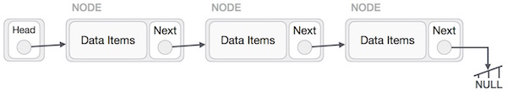

As per the above illustration, following are the important points to be considered.

* Linked List contains a link element called first.
* Each link carries a data field(s) and two link fields called next and prev.
* Each link is linked with its next link using its next link.
* Last link carries a link as null to mark the end of the list.

**Types of Linked List**

Following are the various types of linked list.

* **Simple Linked List** − Item navigation is forward only.
* **Doubly Linked List** − Items can be navigated forward and backward.
* **Circular Linked List** − Last item contains link of the first element as next and the first element has a link to the last element as previous.

**Basic Operations**

Following are the basic operations supported by a list.

* **Insertion** − Adds an element at the beginning of the list.
* **Deletion** − Deletes an element at the beginning of the list.
* **Display** − Displays the complete list.
* **Search** − Searches an element using the given key.
* **Delete** − Deletes an element using the given key.

**Insertion Operation**

Adding a new node in linked list is a more than one step activity. We shall learn this with diagrams here. First, create a node using the same structure and find the location where it has to be inserted.

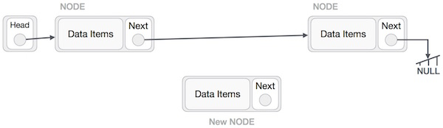

Imagine that we are inserting a node **B** (NewNode), between **A** (LeftNode) and **C** (RightNode). Then point B.next to C −

NewNode.next −> RightNode;

It should look like this −

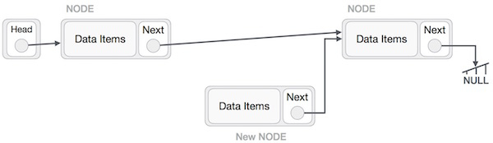

Now, the next node at the left should point to the new node.

LeftNode.next −> NewNode;

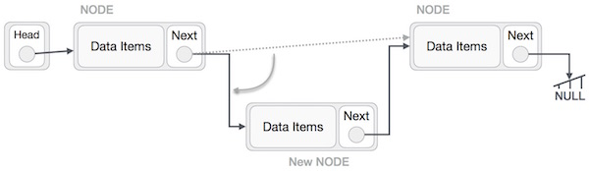

This will put the new node in the middle of the two. The new list should look like this −

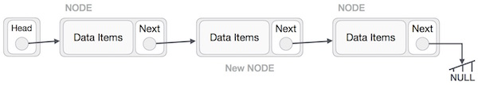

Similar steps should be taken if the node is being inserted at the beginning of the list. While inserting it at the end, the second last node of the list should point to the new node and the new node will point to NULL.

**Deletion Operation**

Deletion is also a more than one step process. We shall learn with pictorial representation. First, locate the target node to be removed, by using searching algorithms.

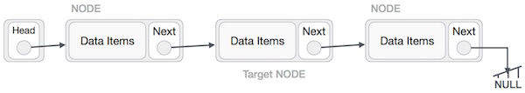

The left (previous) node of the target node now should point to the next node of the target node −

LeftNode.next −> TargetNode.next;

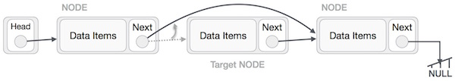

This will remove the link that was pointing to the target node. Now, using the following code, we will remove what the target node is pointing at.

TargetNode.next −> NULL;

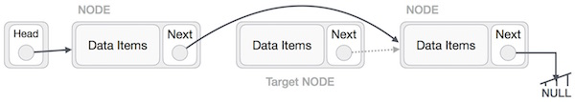

We need to use the deleted node. We can keep that in memory otherwise we can simply deallocate memory and wipe off the target node completely.

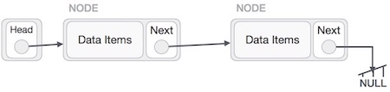

**Reverse Operation**

This operation is a thorough one. We need to make the last node to be pointed by the head node and reverse the whole linked list.

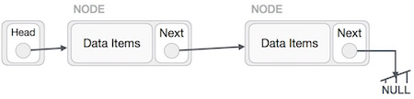

First, we traverse to the end of the list. It should be pointing to NULL. Now, we shall make it point to its previous node −

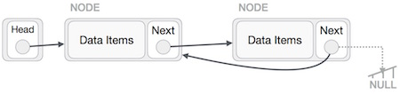

We have to make sure that the last node is not the lost node. So we'll have some temp node, which looks like the head node pointing to the last node. Now, we shall make all left side nodes point to their previous nodes one by one.

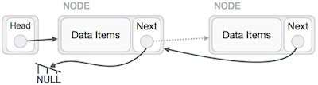

Except the node (first node) pointed by the head node, all nodes should point to their predecessor, making them their new successor. The first node will point to NULL.

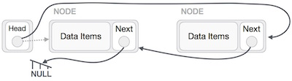

We'll make the head node point to the new first node by using the temp node.

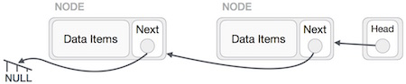

The linked list is now reversed. To see linked list implementation in C programming language, please see below:

A linked list is a sequence of data structures, which are connected via links. Linked List is a sequence of links which contains items. Each link contains a connection to another link. Linked list is the second most-used data structure after array.

Implementation in C

#include <stdio.h>

#include <string.h>

#include <stdlib.h>

#include <stdbool.h>

struct node {

int data;

int key;

struct node *next;

};

struct node *head = NULL;

struct node *current = NULL;

//display the list

void printList() {

struct node *ptr = head;

printf("\n[ ");

//start from the beginning

while(ptr != NULL) {

printf("(%d,%d) ",ptr->key,ptr->data);

ptr = ptr->next;

}

printf(" ]");

}

//insert link at the first location

void insertFirst(int key, int data) {

//create a link

struct node *link = (struct node*) malloc(sizeof(struct node));

link->key = key;

link->data = data;

//point it to old first node

link->next = head;

//point first to new first node

head = link;

}

//delete first item

struct node* deleteFirst() {

//save reference to first link

struct node *tempLink = head;

//mark next to first link as first

head = head->next;

//return the deleted link

return tempLink;

}

//is list empty

bool isEmpty() {

return head == NULL;

}

int length() {

int length = 0;

struct node *current;

for(current = head; current != NULL; current = current->next) {

length++;

}

return length;

}

//find a link with given key

struct node* find(int key) {

//start from the first link

struct node* current = head;

//if list is empty

if(head == NULL) {

return NULL;

}

//navigate through list

while(current->key != key) {

//if it is last node

if(current->next == NULL) {

return NULL;

} else {

//go to next link

current = current->next;

}

}

//if data found, return the current Link

return current;

}

//delete a link with given key

struct node* delete(int key) {

//start from the first link

struct node* current = head;

struct node* previous = NULL;

//if list is empty

if(head == NULL) {

return NULL;

}

//navigate through list

while(current->key != key) {

//if it is last node

if(current->next == NULL) {

return NULL;

} else {

//store reference to current link

previous = current;

//move to next link

current = current->next;

}

}

//found a match, update the link

if(current == head) {

//change first to point to next link

head = head->next;

} else {

//bypass the current link

previous->next = current->next;

}

return current;

}

void sort() {

int i, j, k, tempKey, tempData;

struct node *current;

struct node *next;

int size = length();

k = size ;

for ( i = 0 ; i < size - 1 ; i++, k-- ) {

current = head;

next = head->next;

for ( j = 1 ; j < k ; j++ ) {

if ( current->data > next->data ) {

tempData = current->data;

current->data = next->data;

next->data = tempData;

tempKey = current->key;

current->key = next->key;

next->key = tempKey;

}

current = current->next;

next = next->next;

}

}

}

void reverse(struct node** head_ref) {

struct node* prev = NULL;

struct node* current = *head_ref;

struct node* next;

while (current != NULL) {

next = current->next;

current->next = prev;

prev = current;

current = next;

}

*head_ref = prev;

}

main() {

insertFirst(1,10);

insertFirst(2,20);

insertFirst(3,30);

insertFirst(4,1);

insertFirst(5,40);

insertFirst(6,56);

printf("Original List: ");

//print list

printList();

while(!isEmpty()) {

struct node *temp = deleteFirst();

printf("\nDeleted value:");

printf("(%d,%d) ",temp->key,temp->data);

}

printf("\nList after deleting all items: ");

printList();

insertFirst(1,10);

insertFirst(2,20);

insertFirst(3,30);

insertFirst(4,1);

insertFirst(5,40);

insertFirst(6,56);

printf("\nRestored List: ");

printList();

printf("\n");

struct node *foundLink = find(4);

if(foundLink != NULL) {

printf("Element found: ");

printf("(%d,%d) ",foundLink->key,foundLink->data);

printf("\n");

} else {

printf("Element not found.");

}

delete(4);

printf("List after deleting an item: ");

printList();

printf("\n");

foundLink = find(4);

if(foundLink != NULL) {

printf("Element found: ");

printf("(%d,%d) ",foundLink->key,foundLink->data);

printf("\n");

} else {

printf("Element not found.");

}

printf("\n");

sort();

printf("List after sorting the data: ");

printList();

reverse(&head);

printf("\nList after reversing the data: ");

printList();

}

If we compile and run the above program, it will produce the following result −

Output

Original List:

[ (6,56) (5,40) (4,1) (3,30) (2,20) (1,10) ]

Deleted value:(6,56)

Deleted value:(5,40)

Deleted value:(4,1)

Deleted value:(3,30)

Deleted value:(2,20)

Deleted value:(1,10)

List after deleting all items:

[ ]

Restored List:

[ (6,56) (5,40) (4,1) (3,30) (2,20) (1,10) ]

Element found: (4,1)

List after deleting an item:

[ (6,56) (5,40) (3,30) (2,20) (1,10) ]

Element not found.

List after sorting the data:

[ (1,10) (2,20) (3,30) (5,40) (6,56) ]

List after reversing the data:

[ (6,56) (5,40) (3,30) (2,20) (1,10) ]

**Lesson Four: Doubly Linked List**

Doubly Linked List is a variation of Linked list in which navigation is possible in both ways, either forward and backward easily as compared to Single Linked List. Following are the important terms to understand the concept of doubly linked list.

* **Link** − Each link of a linked list can store a data called an element.
* **Next** − Each link of a linked list contains a link to the next link called Next.
* **Prev** − Each link of a linked list contains a link to the previous link called Prev.
* **LinkedList** − A Linked List contains the connection link to the first link called First and to the last link called Last.

**Doubly Linked List Representation**

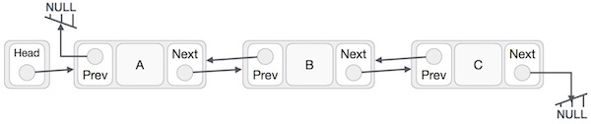

As per the above illustration, following are the important points to be considered.

* Doubly Linked List contains a link element called first and last.
* Each link carries a data field(s) and two link fields called next and prev.
* Each link is linked with its next link using its next link.
* Each link is linked with its previous link using its previous link.
* The last link carries a link as null to mark the end of the list.

**Basic Operations**

Following are the basic operations supported by a list.

* **Insertion** − Adds an element at the beginning of the list.
* **Deletion** − Deletes an element at the beginning of the list.
* **Insert Last** − Adds an element at the end of the list.
* **Delete Last** − Deletes an element from the end of the list.
* **Insert After** − Adds an element after an item of the list.
* **Delete** − Deletes an element from the list using the key.
* **Display forward** − Displays the complete list in a forward manner.
* **Display backward** − Displays the complete list in a backward manner.

**Insertion Operation**

Following code demonstrates the insertion operation at the beginning of a doubly linked list.

**Example**

**//insert link at the first location**

**void insertFirst(int key, int data) {**

**//create a link**

**struct node *link = (struct node*) malloc(sizeof(struct node));**

**link->key = key;**

**link->data = data;**

**if(isEmpty()) {**

**//make it the last link**

**last = link;**

**} else {**

**//update first prev link**

**head->prev = link;**

**}**

**//point it to old first link**

**link->next = head;**

**//point first to new first link**

**head = link;**

**}**

**Deletion Operation**

Following code demonstrates the deletion operation at the beginning of a doubly linked list.

**Example**

//delete first item

struct node* deleteFirst() {

//save reference to first link

struct node *tempLink = head;

//if only one link

if(head->next == NULL) {

last = NULL;

} else {

head->next->prev = NULL;

}

head = head->next;

//return the deleted link

return tempLink;

}

**Insertion at the End of an Operation**

Following code demonstrates the insertion operation at the last position of a doubly linked list.

**Example**

//insert link at the last location

void insertLast(int key, int data) {

//create a link

struct node *link = (struct node*) malloc(sizeof(struct node));

link->key = key;

link->data = data;

if(isEmpty()) {

//make it the last link

last = link;

} else {

//make link a new last link

last->next = link;

//mark old last node as prev of new link

link->prev = last;

}

//point last to new last node

last = link;

}

Doubly Linked List is a variation of Linked list in which navigation is possible in both ways, either forward and backward easily as compared to Single Linked List.

Implementation in C

#include <stdio.h>

#include <string.h>

#include <stdlib.h>

#include <stdbool.h>

struct node {

int data;

int key;

struct node *next;

struct node *prev;

};

//this link always point to first Link

struct node *head = NULL;

//this link always point to last Link

struct node *last = NULL;

struct node *current = NULL;

//is list empty

bool isEmpty() {

return head == NULL;

}

int length() {

int length = 0;

struct node *current;

for(current = head; current != NULL; current = current->next){

length++;

}

return length;

}

//display the list in from first to last

void displayForward() {

//start from the beginning

struct node *ptr = head;

//navigate till the end of the list

printf("\n[ ");

while(ptr != NULL) {

printf("(%d,%d) ",ptr->key,ptr->data);

ptr = ptr->next;

}

printf(" ]");

}

//display the list from last to first

void displayBackward() {

//start from the last

struct node *ptr = last;

//navigate till the start of the list

printf("\n[ ");

while(ptr != NULL) {

//print data

printf("(%d,%d) ",ptr->key,ptr->data);

//move to next item

ptr = ptr ->prev;

printf(" ");

}

printf(" ]");

}

//insert link at the first location

void insertFirst(int key, int data) {

//create a link

struct node *link = (struct node*) malloc(sizeof(struct node));

link->key = key;

link->data = data;

if(isEmpty()) {

//make it the last link

last = link;

} else {

//update first prev link

head->prev = link;

}

//point it to old first link

link->next = head;

//point first to new first link

head = link;

}

//insert link at the last location

void insertLast(int key, int data) {

//create a link

struct node *link = (struct node*) malloc(sizeof(struct node));

link->key = key;

link->data = data;

if(isEmpty()) {

//make it the last link

last = link;

} else {

//make link a new last link

last->next = link;

//mark old last node as prev of new link

link->prev = last;

}

//point last to new last node

last = link;

}

//delete first item

struct node* deleteFirst() {

//save reference to first link

struct node *tempLink = head;

//if only one link

if(head->next == NULL){

last = NULL;

} else {

head->next->prev = NULL;

}

head = head->next;

//return the deleted link

return tempLink;

}

//delete link at the last location

struct node* deleteLast() {

//save reference to last link

struct node *tempLink = last;

//if only one link

if(head->next == NULL) {

head = NULL;

} else {

last->prev->next = NULL;

}

last = last->prev;

//return the deleted link

return tempLink;

}

//delete a link with given key

struct node* delete(int key) {

//start from the first link

struct node* current = head;

struct node* previous = NULL;

//if list is empty

if(head == NULL) {

return NULL;

}

//navigate through list

while(current->key != key) {

//if it is last node

if(current->next == NULL) {

return NULL;

} else {

//store reference to current link

previous = current;

//move to next link

current = current->next;

}

}

//found a match, update the link

if(current == head) {

//change first to point to next link

head = head->next;

} else {

//bypass the current link

current->prev->next = current->next;

}

if(current == last) {

//change last to point to prev link

last = current->prev;

} else {

current->next->prev = current->prev;

}

return current;

}

bool insertAfter(int key, int newKey, int data) {

//start from the first link

struct node *current = head;

//if list is empty

if(head == NULL) {

return false;

}

//navigate through list

while(current->key != key) {

//if it is last node

if(current->next == NULL) {

return false;

} else {

//move to next link

current = current->next;

}

}

//create a link

struct node *newLink = (struct node*) malloc(sizeof(struct node));

newLink->key = newKey;

newLink->data = data;

if(current == last) {

newLink->next = NULL;

last = newLink;

} else {

newLink->next = current->next;

current->next->prev = newLink;

}

newLink->prev = current;

current->next = newLink;

return true;

}

main() {

insertFirst(1,10);

insertFirst(2,20);

insertFirst(3,30);

insertFirst(4,1);

insertFirst(5,40);

insertFirst(6,56);

printf("\nList (First to Last): ");

displayForward();

printf("\n");

printf("\nList (Last to first): ");

displayBackward();

printf("\nList , after deleting first record: ");

deleteFirst();

displayForward();

printf("\nList , after deleting last record: ");

deleteLast();

displayForward();

printf("\nList , insert after key(4) : ");

insertAfter(4,7, 13);

displayForward();

printf("\nList , after delete key(4) : ");

delete(4);

displayForward();

}

If we compile and run the above program, it will produce the following result −

Output

List (First to Last):

[ (6,56) (5,40) (4,1) (3,30) (2,20) (1,10) ]

List (Last to first):

[ (1,10) (2,20) (3,30) (4,1) (5,40) (6,56) ]

List , after deleting first record:

[ (5,40) (4,1) (3,30) (2,20) (1,10) ]

List , after deleting last record:

[ (5,40) (4,1) (3,30) (2,20) ]

List , insert after key(4) :

[ (5,40) (4,1) (4,13) (3,30) (2,20) ]

List , after delete key(4) :

[ (5,40) (4,13) (3,30) (2,20) ]

**Lesson Five: Circular Linked List**

Circular Linked List is a variation of Linked list in which the first element points to the last element and the last element points to the first element. Both Singly Linked List and Doubly Linked List can be made into a circular linked list.

**Singly Linked List as Circular**

In singly linked list, the next pointer of the last node points to the first node.

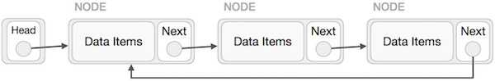

**Doubly Linked List as Circular**

In doubly linked list, the next pointer of the last node points to the first node and the previous pointer of the first node points to the last node making the circular in both directions.

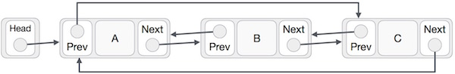

As per the above illustration, following are the important points to be considered.

* The last link's next points to the first link of the list in both cases of singly as well as doubly linked list.
* The first link's previous points to the last of the list in case of doubly linked list.

**Basic Operations**

Following are the important operations supported by a circular list.

* **insert** − Inserts an element at the start of the list.
* **delete** − Deletes an element from the start of the list.
* **display** − Displays the list.

**Insertion Operation**

Following code demonstrates the insertion operation in a circular linked list based on single linked list.

**Example**

//insert link at the first location

void insertFirst(int key, int data) {

//create a link

struct node *link = (struct node*) malloc(sizeof(struct node));

link->key = key;

link->data= data;

if (isEmpty()) {

head = link;

head->next = head;

} else {

//point it to old first node

link->next = head;

//point first to new first node

head = link;

}

}

**Deletion Operation**

Following code demonstrates the deletion operation in a circular linked list based on single linked list.

//delete first item

struct node * deleteFirst() {

//save reference to first link

struct node *tempLink = head;

if(head->next == head) {

head = NULL;

return tempLink;

}

//mark next to first link as first

head = head->next;

//return the deleted link

return tempLink;

}

**Display List Operation**

Following code demonstrates the display list operation in a circular linked list.

//display the list

void printList() {

struct node *ptr = head;

printf("\n[ ");

//start from the beginning

if(head != NULL) {

while(ptr->next != ptr) {

printf("(%d,%d) ",ptr->key,ptr->data);

ptr = ptr->next;

}

}

printf(" ]");

}

Circular Linked List is a variation of Linked list in which the first element points to the last element and the last element points to the first element. Both Singly Linked List and Doubly Linked List can be made into a circular linked list.

Implementation in C

#include <stdio.h>

#include <string.h>

#include <stdlib.h>

#include <stdbool.h>

struct node {

int data;

int key;

struct node *next;

};

struct node *head = NULL;

struct node *current = NULL;

bool isEmpty() {

return head == NULL;

}

int length() {

int length = 0;

//if list is empty

if(head == NULL) {

return 0;

}

current = head->next;

while(current != head) {

length++;

current = current->next;

}

return length;

}

//insert link at the first location

void insertFirst(int key, int data) {

//create a link

struct node *link = (struct node*) malloc(sizeof(struct node));

link->key = key;

link->data = data;

if (isEmpty()) {

head = link;

head->next = head;

} else {

//point it to old first node

link->next = head;

//point first to new first node

head = link;

}

}

//delete first item

struct node * deleteFirst() {

//save reference to first link

struct node *tempLink = head;

if(head->next == head) {

head = NULL;

return tempLink;

}

//mark next to first link as first

head = head->next;

//return the deleted link

return tempLink;

}

//display the list

void printList() {

struct node *ptr = head;

printf("\n[ ");

//start from the beginning

if(head != NULL) {

while(ptr->next != ptr) {

printf("(%d,%d) ",ptr->key,ptr->data);

ptr = ptr->next;

}

}

printf(" ]");

}

main() {

insertFirst(1,10);

insertFirst(2,20);

insertFirst(3,30);

insertFirst(4,1);

insertFirst(5,40);

insertFirst(6,56);

printf("Original List: ");

//print list

printList();

while(!isEmpty()) {

struct node *temp = deleteFirst();

printf("\nDeleted value:");

printf("(%d,%d) ",temp->key,temp->data);

}

printf("\nList after deleting all items: ");

printList();

}

If we compile and run the above program, it will produce the following result −

Output

Original List:

[ (6,56) (5,40) (4,1) (3,30) (2,20) ]

Deleted value:(6,56)

Deleted value:(5,40)

Deleted value:(4,1)

Deleted value:(3,30)

Deleted value:(2,20)

Deleted value:(1,10)

List after deleting all items:

[ ]

**Lesson Six: Stack**

A stack is an Abstract Data Type (ADT), commonly used in most programming languages. It is named stack as it behaves like a real-world stack, for example – a deck of cards or a pile of plates, etc.



A real-world stack allows operations at one end only. For example, we can place or remove a card or plate from the top of the stack only. Likewise, Stack ADT allows all data operations at one end only. At any given time, we can only access the top element of a stack.

This feature makes it LIFO data structure. LIFO stands for Last-in-first-out. Here, the element which is placed (inserted or added) last, is accessed first. In stack terminology, insertion operation is called **PUSH** operation and removal operation is called **POP** operation.

**Stack Representation**

The following diagram depicts a stack and its operations −

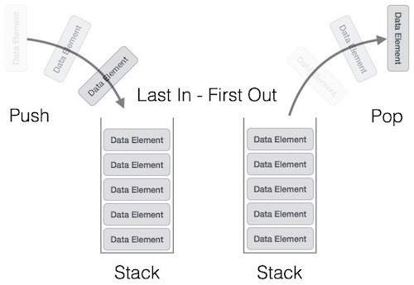

A stack can be implemented by means of Array, Structure, Pointer, and Linked List. Stack can either be a fixed size one or it may have a sense of dynamic resizing. Here, we are going to implement stack using arrays, which makes it a fixed size stack implementation.

**Basic Operations**

Stack operations may involve initializing the stack, using it and then de-initializing it. Apart from these basic stuffs, a stack is used for the following two primary operations −

* **push()** − Pushing (storing) an element on the stack.
* **pop()** − Removing (accessing) an element from the stack.

When data is PUSHed onto stack.

To use a stack efficiently, we need to check the status of stack as well. For the same purpose, the following functionality is added to stacks −

* **peek()** − get the top data element of the stack, without removing it.
* **isFull()** − check if stack is full.
* **isEmpty()** − check if stack is empty.

At all times, we maintain a pointer to the last PUSHed data on the stack. As this pointer always represents the top of the stack, hence named **top**. The **top** pointer provides top value of the stack without actually removing it.

First we should learn about procedures to support stack functions −

**peek()**

Algorithm of peek() function −

begin procedure peek

return stack[top]

end procedure

Implementation of peek() function in C programming language −

**Example**

int peek() {

return stack[top];

}

**isfull()**

Algorithm of isfull() function −

begin procedure isfull

if top equals to MAXSIZE

return true

else

return false

endif

end procedure

Implementation of isfull() function in C programming language −

**Example**

bool isfull() {

if(top == MAXSIZE)

return true;

else

return false;

}

**isempty()**

Algorithm of isempty() function −

begin procedure isempty

if top less than 1

return true

else

return false

endif

end procedure

Implementation of isempty() function in C programming language is slightly different. We initialize top at -1, as the index in array starts from 0. So we check if the top is below zero or -1 to determine if the stack is empty. Here's the code −

**Example**

bool isempty() {

if(top == -1)

return true;

else

return false;

}

**Push Operation**

The process of putting a new data element onto stack is known as a Push Operation. Push operation involves a series of steps −

* **Step 1** − Checks if the stack is full.
* **Step 2** − If the stack is full, produces an error and exit.
* **Step 3** − If the stack is not full, increments **top** to point next empty space.
* **Step 4** − Adds data element to the stack location, where top is pointing.
* **Step 5** − Returns success.

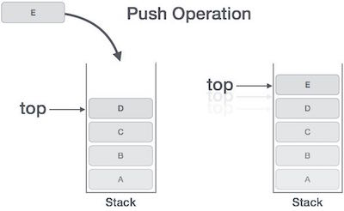

If the linked list is used to implement the stack, then in step 3, we need to allocate space dynamically.

**Algorithm for PUSH Operation**

A simple algorithm for Push operation can be derived as follows −

begin procedure push: stack, data

if stack is full

return null

endif

top ← top + 1

stack[top] ← data

end procedure

Implementation of this algorithm in C, is very easy. See the following code −

**Example**

void push(int data) {

if(!isFull()) {

top = top + 1;

stack[top] = data;

} else {

printf("Could not insert data, Stack is full.\n");

}

}

**Pop Operation**

Accessing the content while removing it from the stack, is known as a Pop Operation. In an array implementation of pop() operation, the data element is not actually removed, instead **top** is decremented to a lower position in the stack to point to the next value. But in linked-list implementation, pop() actually removes data element and deallocates memory space.

A Pop operation may involve the following steps −

* **Step 1** − Checks if the stack is empty.
* **Step 2** − If the stack is empty, produces an error and exit.
* **Step 3** − If the stack is not empty, accesses the data element at which **top** is pointing.
* **Step 4** − Decreases the value of top by 1.
* **Step 5** − Returns success.

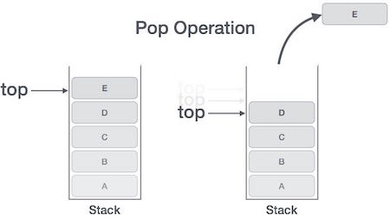

**Algorithm for Pop Operation**

A simple algorithm for Pop operation can be derived as follows −

begin procedure pop: stack

if stack is empty

return null

endif

data ← stack[top]

top ← top - 1

return data

end procedure

Implementation of this algorithm in C, is as follows −

**Example**

int pop(int data) {

if(!isempty()) {

data = stack[top];

top = top - 1;

return data;

} else {

printf("Could not retrieve data, Stack is empty.\n");

}

}

We shall see the stack implementation in C programming language here. You can try the program by clicking on the Try-it button. To learn the theory aspect of stacks, click on visit previous page.

Implementation in C

#include <stdio.h>

int MAXSIZE = 8;

int stack[8];

int top = -1;

int isempty() {

if(top == -1)

return 1;

else

return 0;

}

int isfull() {

if(top == MAXSIZE)

return 1;

else

return 0;

}

int peek() {

return stack[top];

}

int pop() {

int data;

if(!isempty()) {

data = stack[top];

top = top - 1;

return data;

} else {

printf("Could not retrieve data, Stack is empty.\n");

}

}

int push(int data) {

if(!isfull()) {

top = top + 1;

stack[top] = data;

} else {

printf("Could not insert data, Stack is full.\n");

}

}

int main() {

// push items on to the stack

push(3);

push(5);

push(9);

push(1);

push(12);

push(15);

printf("Element at top of the stack: %d\n" ,peek());

printf("Elements: \n");

// print stack data

while(!isempty()) {

int data = pop();

printf("%d\n",data);

}

printf("Stack full: %s\n" , isfull()?"true":"false");

printf("Stack empty: %s\n" , isempty()?"true":"false");

return 0;

}

If we compile and run the above program, it will produce the following result −

Output

Element at top of the stack: 15

Elements:

15

12

1

9

5

3

Stack full: false

Stack empty: true

**Lesson Seven: Queue**

Queue is an abstract data structure, somewhat similar to Stacks. Unlike stacks, a queue is open at both its ends. One end is always used to insert data (enqueue) and the other is used to remove data (dequeue). Queue follows First-In-First-Out methodology, i.e., the data item stored first will be accessed first.



A real-world example of queue can be a single-lane one-way road, where the vehicle enters first, exits first. More real-world examples can be seen as queues at the ticket windows and bus-stops.

**Queue Representation**

As we now understand that in queue, we access both ends for different reasons. The following diagram given below tries to explain queue representation as data structure −

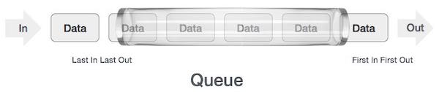

As in stacks, a queue can also be implemented using Arrays, Linked-lists, Pointers and Structures. For the sake of simplicity, we shall implement queues using one-dimensional array.

**Basic Operations**

Queue operations may involve initializing or defining the queue, utilizing it, and then completely erasing it from the memory. Here we shall try to understand the basic operations associated with queues −

* **enqueue()** − add (store) an item to the queue.
* **dequeue()** − remove (access) an item from the queue.

Few more functions are required to make the above-mentioned queue operation efficient. These are −

* **peek()** − Gets the element at the front of the queue without removing it.
* **isfull()** − Checks if the queue is full.
* **isempty()** − Checks if the queue is empty.

In queue, we always dequeue (or access) data, pointed by **front** pointer and while enqueing (or storing) data in the queue we take help of **rear** pointer.

Let's first learn about supportive functions of a queue −

**peek()**

This function helps to see the data at the **front** of the queue. The algorithm of peek() function is as follows −

**Algorithm**

begin procedure peek

return queue[front]

end procedure

Implementation of peek() function in C programming language −

**Example**

int peek() {

return queue[front];

}

**isfull()**

As we are using single dimension array to implement queue, we just check for the rear pointer to reach at MAXSIZE to determine that the queue is full. In case we maintain the queue in a circular linked-list, the algorithm will differ. Algorithm of isfull() function −

**Algorithm**

begin procedure isfull

if rear equals to MAXSIZE

return true

else

return false

endif

end procedure

Implementation of isfull() function in C programming language −

**Example**

bool isfull() {

if(rear == MAXSIZE - 1)

return true;

else

return false;

}

**isempty()**

Algorithm of isempty() function −

**Algorithm**

begin procedure isempty

if front is less than MIN OR front is greater than rear

return true

else

return false

endif

end procedure

If the value of **front** is less than MIN or 0, it tells that the queue is not yet initialized, hence empty.

Here's the C programming code −

**Example**

bool isempty() {

if(front < 0 || front > rear)

return true;

else

return false;

}

**Enqueue Operation**

Queues maintain two data pointers, **front** and **rear**. Therefore, its operations are comparatively difficult to implement than that of stacks.

The following steps should be taken to enqueue (insert) data into a queue −

* **Step 1** − Check if the queue is full.
* **Step 2** − If the queue is full, produce overflow error and exit.
* **Step 3** − If the queue is not full, increment **rear** pointer to point the next empty space.
* **Step 4** − Add data element to the queue location, where the rear is pointing.
* **Step 5** − return success.

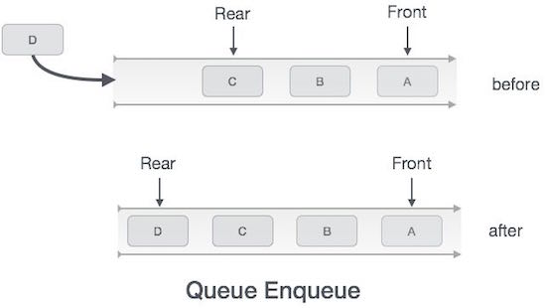

Sometimes, we also check to see if a queue is initialized or not, to handle any unforeseen situations.

**Algorithm for enqueue operation**

procedure enqueue(data)

if queue is full

return overflow

endif

rear ← rear + 1

queue[rear] ← data

return true

end procedure

Implementation of enqueue() in C programming language −

**Example**

int enqueue(int data)

if(isfull())

return 0;

rear = rear + 1;

queue[rear] = data;

return 1;

**Dequeue Operation**

Accessing data from the queue is a process of two tasks − access the data where **front** is pointing and remove the data after access. The following steps are taken to perform **dequeue** operation −

* **Step 1** − Check if the queue is empty.
* **Step 2** − If the queue is empty, produce underflow error and exit.
* **Step 3** − If the queue is not empty, access the data where **front** is pointing.
* **Step 4** − Increment **front** pointer to point to the next available data element.
* **Step 5** − Return success.

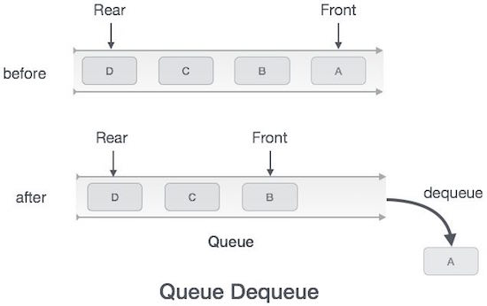

**Algorithm for dequeue operation**

procedure dequeue

if queue is empty

return underflow

end if

data = queue[front]

front ← front + 1

return true

end procedure

Implementation of dequeue() in C programming language −

**Example**

int dequeue() {

if(isempty())

return 0;

int data = queue[front];

front = front + 1;

return data;

}

For a complete Queue program in C programming language, see below

Implementation in C

#include <stdio.h>

#include <string.h>

#include <stdlib.h>

#include <stdbool.h>

#define MAX 6

int intArray[MAX];

int front = 0;

int rear = -1;

int itemCount = 0;

int peek() {

return intArray[front];

}

bool isEmpty() {

return itemCount == 0;

}

bool isFull() {

return itemCount == MAX;

}

int size() {

return itemCount;

}

void insert(int data) {

if(!isFull()) {

if(rear == MAX-1) {

rear = -1;

}

intArray[++rear] = data;

itemCount++;

}

}

int removeData() {

int data = intArray[front++];

if(front == MAX) {

front = 0;

}

itemCount--;

return data;

}

int main() {

/* insert 5 items */

insert(3);

insert(5);

insert(9);

insert(1);

insert(12);

// front : 0

// rear : 4

// ------------------

// index : 0 1 2 3 4

// ------------------

// queue : 3 5 9 1 12

insert(15);

// front : 0

// rear : 5

// ---------------------

// index : 0 1 2 3 4 5

// ---------------------

// queue : 3 5 9 1 12 15

if(isFull()){

printf("Queue is full!\n");

}

// remove one item

int num = removeData();

printf("Element removed: %d\n",num);

// front : 1

// rear : 5

// -------------------

// index : 1 2 3 4 5

// -------------------

// queue : 5 9 1 12 15

// insert more items

insert(16);

// front : 1

// rear : -1

// ----------------------

// index : 0 1 2 3 4 5

// ----------------------

// queue : 16 5 9 1 12 15

// As queue is full, elements will not be inserted.

insert(17);

insert(18);

// ----------------------

// index : 0 1 2 3 4 5

// ----------------------

// queue : 16 5 9 1 12 15

printf("Element at front: %d\n",peek());

printf("----------------------\n");

printf("index : 5 4 3 2 1 0\n");

printf("----------------------\n");

printf("Queue: ");

while(!isEmpty()) {

int n = removeData();

printf("%d ",n);

}

}

If we compile and run the above program, it will produce the following result −

Output

Queue is full!

Element removed: 3

Element at front: 5

----------------------

index : 5 4 3 2 1 0

----------------------

Queue: 5 9 1 12 15 16

**Lesson Ten: Hash Table**

Hash Table is a data structure which stores data in an associative manner. In a hash table, data is stored in an array format, where each data value has its own unique index value. Access of data becomes very fast if we know the index of the desired data.

Thus, it becomes a data structure in which insertion and search operations are very fast irrespective of the size of the data. Hash Table uses an array as a storage medium and uses hash technique to generate an index where an element is to be inserted or is to be located from.

**Hashing**

Hashing is a technique to convert a range of key values into a range of indexes of an array. We're going to use modulo operator to get a range of key values. Consider an example of hash table of size 20, and the following items are to be stored. Item are in the (key,value) format.

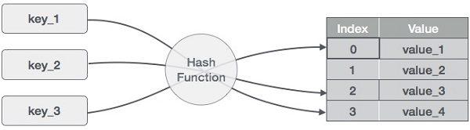

* (1,20)
* (2,70)
* (42,80)
* (4,25)
* (12,44)
* (14,32)
* (17,11)
* (13,78)
* (37,98)

|  |  |  |  |
| --- | --- | --- | --- |
| **Sr. No.** | **Key** | **Hash** | **Array Index** |
| 1 | 1 | 1 % 20 = 1 | 1 |
| 2 | 2 | 2 % 20 = 2 | 2 |
| 3 | 42 | 42 % 20 = 2 | 2 |
| 4 | 4 | 4 % 20 = 4 | 4 |
| 5 | 12 | 12 % 20 = 12 | 12 |
| 6 | 14 | 14 % 20 = 14 | 14 |
| 7 | 17 | 17 % 20 = 17 | 17 |
| 8 | 13 | 13 % 20 = 13 | 13 |
| 9 | 37 | 37 % 20 = 17 | 17 |

**Linear Probing**

As we can see, it may happen that the hashing technique is used to create an already used index of the array. In such a case, we can search the next empty location in the array by looking into the next cell until we find an empty cell. This technique is called linear probing.

|  |  |  |  |  |
| --- | --- | --- | --- | --- |
| **Sr. No.** | **Key** | **Hash** | **Array Index** | **After Linear Probing, Array Index** |
| 1 | 1 | 1 % 20 = 1 | 1 | 1 |
| 2 | 2 | 2 % 20 = 2 | 2 | 2 |
| 3 | 42 | 42 % 20 = 2 | 2 | 3 |
| 4 | 4 | 4 % 20 = 4 | 4 | 4 |
| 5 | 12 | 12 % 20 = 12 | 12 | 12 |
| 6 | 14 | 14 % 20 = 14 | 14 | 14 |
| 7 | 17 | 17 % 20 = 17 | 17 | 17 |
| 8 | 13 | 13 % 20 = 13 | 13 | 13 |
| 9 | 37 | 37 % 20 = 17 | 17 | 18 |

**Basic Operations**

Following are the basic primary operations of a hash table.

* **Search** − Searches an element in a hash table.
* **Insert** − inserts an element in a hash table.
* **delete** − Deletes an element from a hash table.

**DataItem**

Define a data item having some data and key, based on which the search is to be conducted in a hash table.

struct DataItem {

int data;

int key;

};

**Hash Method**

Define a hashing method to compute the hash code of the key of the data item.

int hashCode(int key){

return key % SIZE;

}

**Search Operation**

Whenever an element is to be searched, compute the hash code of the key passed and locate the element using that hash code as index in the array. Use linear probing to get the element ahead if the element is not found at the computed hash code.

**Example**

struct DataItem *search(int key) {

//get the hash

int hashIndex = hashCode(key);

//move in array until an empty

while(hashArray[hashIndex] != NULL) {

if(hashArray[hashIndex]->key == key)

return hashArray[hashIndex];

//go to next cell

++hashIndex;

//wrap around the table

hashIndex %= SIZE;

}

return NULL;

}

**Insert Operation**

Whenever an element is to be inserted, compute the hash code of the key passed and locate the index using that hash code as an index in the array. Use linear probing for empty location, if an element is found at the computed hash code.

**Example**

void insert(int key,int data) {

struct DataItem *item = (struct DataItem*) malloc(sizeof(struct DataItem));

item->data = data;

item->key = key;

//get the hash

int hashIndex = hashCode(key);

//move in array until an empty or deleted cell

while(hashArray[hashIndex] != NULL && hashArray[hashIndex]->key != -1) {

//go to next cell

++hashIndex;

//wrap around the table

hashIndex %= SIZE;

}

hashArray[hashIndex] = item;

}

**Delete Operation**

Whenever an element is to be deleted, compute the hash code of the key passed and locate the index using that hash code as an index in the array. Use linear probing to get the element ahead if an element is not found at the computed hash code. When found, store a dummy item there to keep the performance of the hash table intact.

**Example**

struct DataItem* delete(struct DataItem* item) {

int key = item->key;

//get the hash

int hashIndex = hashCode(key);

//move in array until an empty

while(hashArray[hashIndex] !=NULL) {

if(hashArray[hashIndex]->key == key) {

struct DataItem* temp = hashArray[hashIndex];

//assign a dummy item at deleted position

hashArray[hashIndex] = dummyItem;

return temp;

}

//go to next cell

++hashIndex;

//wrap around the table

hashIndex %= SIZE;

}

return NULL;

}

Hash Table is a data structure which stores data in an associative manner. In hash table, the data is stored in an array format where each data value has its own unique index value. Access of data becomes very fast, if we know the index of the desired data.

Implementation in C

#include <stdio.h>

#include <string.h>

#include <stdlib.h>

#include <stdbool.h>

#define SIZE 20

struct DataItem {

int data;

int key;

};

struct DataItem* hashArray[SIZE];

struct DataItem* dummyItem;

struct DataItem* item;

int hashCode(int key) {

return key % SIZE;

}

struct DataItem *search(int key) {

//get the hash

int hashIndex = hashCode(key);

//move in array until an empty

while(hashArray[hashIndex] != NULL) {

if(hashArray[hashIndex]->key == key)

return hashArray[hashIndex];

//go to next cell

++hashIndex;

//wrap around the table

hashIndex %= SIZE;

}

return NULL;

}

void insert(int key,int data) {

struct DataItem *item = (struct DataItem*) malloc(sizeof(struct DataItem));

item->data = data;

item->key = key;

//get the hash

int hashIndex = hashCode(key);

//move in array until an empty or deleted cell

while(hashArray[hashIndex] != NULL && hashArray[hashIndex]->key != -1) {

//go to next cell

++hashIndex;

//wrap around the table

hashIndex %= SIZE;

}

hashArray[hashIndex] = item;

}

struct DataItem* delete(struct DataItem* item) {

int key = item->key;

//get the hash

int hashIndex = hashCode(key);

//move in array until an empty

while(hashArray[hashIndex] != NULL) {

if(hashArray[hashIndex]->key == key) {

struct DataItem* temp = hashArray[hashIndex];

//assign a dummy item at deleted position

hashArray[hashIndex] = dummyItem;

return temp;

}

//go to next cell

++hashIndex;

//wrap around the table

hashIndex %= SIZE;

}

return NULL;

}

void display() {

int i = 0;

for(i = 0; i<SIZE; i++) {

if(hashArray[i] != NULL)

printf(" (%d,%d)",hashArray[i]->key,hashArray[i]->data);

else

printf(" ~~ ");

}

printf("\n");

}

int main() {

dummyItem = (struct DataItem*) malloc(sizeof(struct DataItem));

dummyItem->data = -1;

dummyItem->key = -1;

insert(1, 20);

insert(2, 70);

insert(42, 80);

insert(4, 25);

insert(12, 44);

insert(14, 32);

insert(17, 11);

insert(13, 78);

insert(37, 97);

display();

item = search(37);

if(item != NULL) {

printf("Element found: %d\n", item->data);

} else {

printf("Element not found\n");

}

delete(item);

item = search(37);

if(item != NULL) {

printf("Element found: %d\n", item->data);

} else {

printf("Element not found\n");

}

}

If we compile and run the above program, it will produce the following result −

Output

~~ (1,20) (2,70) (42,80) (4,25) ~~ ~~ ~~ ~~ ~~ ~~ ~~ (12,44) (13,78) (14,32) ~~ ~~ (17,11) (37,97) ~~

Element found: 97

Element not found

**Lesson Seventeen: Graph Data Structure**

A graph is a pictorial representation of a set of objects where some pairs of objects are connected by links. The interconnected objects are represented by points termed as **vertices**, and the links that connect the vertices are called **edges**.

Formally, a graph is a pair of sets **(V, E)**, where **V** is the set of vertices and **E** is the set of edges, connecting the pairs of vertices. Take a look at the following graph −

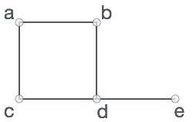

In the above graph,

V = {a, b, c, d, e}

E = {ab, ac, bd, cd, de}

**Graph Data Structure**

Mathematical graphs can be represented in data structure. We can represent a graph using an array of vertices and a two-dimensional array of edges. Before we proceed further, let's familiarize ourselves with some important terms −

* **Vertex** − Each node of the graph is represented as a vertex. In the following example, the labeled circle represents vertices. Thus, A to G are vertices. We can represent them using an array as shown in the following image. Here A can be identified by index 0. B can be identified using index 1 and so on.
* **Edge** − Edge represents a path between two vertices or a line between two vertices. In the following example, the lines from A to B, B to C, and so on represents edges. We can use a two-dimensional array to represent an array as shown in the following image. Here AB can be represented as 1 at row 0, column 1, BC as 1 at row 1, column 2 and so on, keeping other combinations as 0.
* **Adjacency** − Two node or vertices are adjacent if they are connected to each other through an edge. In the following example, B is adjacent to A, C is adjacent to B, and so on.
* **Path** − Path represents a sequence of edges between the two vertices. In the following example, ABCD represents a path from A to D.

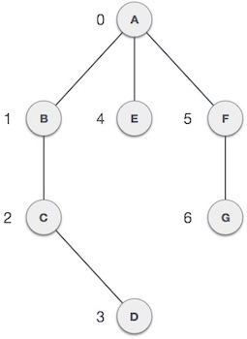

**Basic Operations**

Following are basic primary operations of a Graph −

* **Add Vertex** − Adds a vertex to the graph.
* **Add Edge** − Adds an edge between the two vertices of the graph.
* **Display Vertex** − Displays a vertex of the graph.

**Depth First Traversal**

Depth First Search (DFS) algorithm traverses a graph in a depthward motion and uses a stack to remember to get the next vertex to start a search, when a dead end occurs in any iteration.

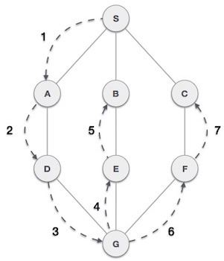

As in the example given above, DFS algorithm traverses from A to B to C to D first then to E, then to F and lastly to G. It employs the following rules.

* **Rule 1** − Visit the adjacent unvisited vertex. Mark it as visited. Display it. Push it in a stack.
* **Rule 2** − If no adjacent vertex is found, pop up a vertex from the stack. (It will pop up all the vertices from the stack, which do not have adjacent vertices.)
* **Rule 3** − Repeat Rule 1 and Rule 2 until the stack is empty.

|  |  |  |
| --- | --- | --- |
| **Step** | **Traversal** | **Description** |
| 1. | Depth First Search Step One | Initialize the stack. |
| 2. | Depth First Search Step Two | Mark **S** as visited and put it onto the stack. Explore any unvisited adjacent node from **S**. We have three nodes and we can pick any of them. For this example, we shall take the node in an alphabetical order. |
| 3. | Depth First Search Step Three | Mark **A** as visited and put it onto the stack. Explore any unvisited adjacent node from A. Both **S** and **D** are adjacent to **A** but we are concerned for unvisited nodes only. |
| 4. | Depth First Search Step Four | Visit **D** and mark it as visited and put onto the stack. Here, we have **B** and **C** nodes, which are adjacent to **D** and both are unvisited. However, we shall again choose in an alphabetical order. |
| 5. | Depth First Search Step Five | We choose **B**, mark it as visited and put onto the stack. Here **B** does not have any unvisited adjacent node. So, we pop **B** from the stack. |
| 6. | Depth First Search Step Six | We check the stack top for return to the previous node and check if it has any unvisited nodes. Here, we find **D** to be on the top of the stack. |
| 7. | Depth First Search Step Seven | Only unvisited adjacent node is from **D** is **C** now. So we visit **C**, mark it as visited and put it onto the stack. |

As **C** does not have any unvisited adjacent node so we keep popping the stack until we find a node that has an unvisited adjacent node. In this case, there's none and we keep popping until the stack is empty.

We shall not see the implementation of Depth First Traversal (or Depth First Search) in C programming language. For our reference purpose, we shall follow our example and take this as our graph model −

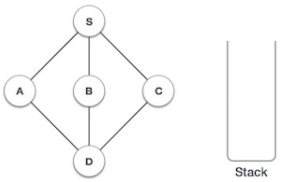

Implementation in C

#include <stdio.h>

#include <stdlib.h>

#include <stdbool.h>

#define MAX 5

struct Vertex {

char label;

bool visited;

};

//stack variables

int stack[MAX];

int top = -1;

//graph variables

//array of vertices

struct Vertex* lstVertices[MAX];

//adjacency matrix

int adjMatrix[MAX][MAX];

//vertex count

int vertexCount = 0;

//stack functions

void push(int item) {

stack[++top] = item;

}

int pop() {

return stack[top--];

}

int peek() {

return stack[top];

}

bool isStackEmpty() {

return top == -1;

}

//graph functions

//add vertex to the vertex list

void addVertex(char label) {

struct Vertex* vertex = (struct Vertex*) malloc(sizeof(struct Vertex));

vertex->label = label;

vertex->visited = false;

lstVertices[vertexCount++] = vertex;

}

//add edge to edge array

void addEdge(int start,int end) {

adjMatrix[start][end] = 1;

adjMatrix[end][start] = 1;

}

//display the vertex

void displayVertex(int vertexIndex) {

printf("%c ",lstVertices[vertexIndex]->label);

}

//get the adjacent unvisited vertex

int getAdjUnvisitedVertex(int vertexIndex) {

int i;

for(i = 0; i<vertexCount; i++) {

if(adjMatrix[vertexIndex][i] == 1 && lstVertices[i]->visited == false) {

return i;

}

}

return -1;

}

void depthFirstSearch() {

int i;

//mark first node as visited

lstVertices[0]->visited = true;

//display the vertex

displayVertex(0);

//push vertex index in stack

push(0);

while(!isStackEmpty()) {

//get the unvisited vertex of vertex which is at top of the stack

int unvisitedVertex = getAdjUnvisitedVertex(peek());

//no adjacent vertex found

if(unvisitedVertex == -1) {

pop();

} else {

lstVertices[unvisitedVertex]->visited = true;

displayVertex(unvisitedVertex);

push(unvisitedVertex);

}

}

//stack is empty, search is complete, reset the visited flag

for(i = 0;i < vertexCount;i++) {

lstVertices[i]->visited = false;

}

}

int main() {

int i, j;

for(i = 0; i<MAX; i++) // set adjacency

{

for(j = 0; j<MAX; j++) // matrix to 0

adjMatrix[i][j] = 0;

}

addVertex('S'); // 0

addVertex('A'); // 1

addVertex('B'); // 2

addVertex('C'); // 3

addVertex('D'); // 4

addEdge(0, 1); // S - A

addEdge(0, 2); // S - B

addEdge(0, 3); // S - C

addEdge(1, 4); // A - D

addEdge(2, 4); // B - D

addEdge(3, 4); // C - D

printf("Depth First Search: ");

depthFirstSearch();

return 0;

}

If we compile and run the above program, it will produce the following result −

Output

Depth First Search: S A D B C

**Breadth First Traversal**

Breadth First Search (BFS) algorithm traverses a graph in a breadthward motion and uses a queue to remember to get the next vertex to start a search, when a dead end occurs in any iteration.

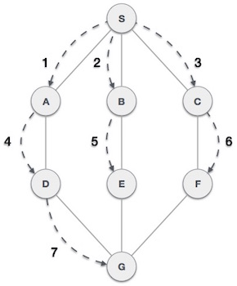

As in the example given above, BFS algorithm traverses from A to B to E to F first then to C and G lastly to D. It employs the following rules.

* **Rule 1** − Visit the adjacent unvisited vertex. Mark it as visited. Display it. Insert it in a queue.
* **Rule 2** − If no adjacent vertex is found, remove the first vertex from the queue.
* **Rule 3** − Repeat Rule 1 and Rule 2 until the queue is empty.

|  |  |  |
| --- | --- | --- |
| **Step** | **Traversal** | **Description** |
| 1. | Breadth First Search Step One | Initialize the queue. |
| 2. | Breadth First Search Step Two | We start from visiting **S** (starting node), and mark it as visited. |
| 3. | Breadth First Search Step Three | We then see an unvisited adjacent node from **S**. In this example, we have three nodes but alphabetically we choose **A**, mark it as visited and enqueue it. |
| 4. | Breadth First Search Step Four | Next, the unvisited adjacent node from **S** is **B**. We mark it as visited and enqueue it. |
| 5. | Breadth First Search Step Five | Next, the unvisited adjacent node from **S** is **C**. We mark it as visited and enqueue it. |
| 6. | Breadth First Search Step Six | Now, **S** is left with no unvisited adjacent nodes. So, we dequeue and find **A**. |
| 7. | Breadth First Search Step Seven | From **A** we have **D** as unvisited adjacent node. We mark it as visited and enqueue it. |

At this stage, we are left with no unmarked (unvisited) nodes. But as per the algorithm we keep on dequeuing in order to get all unvisited nodes. When the queue gets emptied, the program is over.

We shall not see the implementation of Breadth First Traversal (or Breadth First Search) in C programming language. For our reference purpose, we shall follow our example and take this as our graph model −

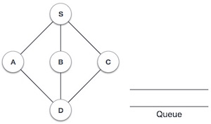

Implementation in C

#include <stdio.h>

#include <stdlib.h>

#include <stdbool.h>

#define MAX 5

struct Vertex {

char label;

bool visited;

};

//queue variables

int queue[MAX];

int rear = -1;

int front = 0;

int queueItemCount = 0;

//graph variables

//array of vertices

struct Vertex* lstVertices[MAX];

//adjacency matrix

int adjMatrix[MAX][MAX];

//vertex count

int vertexCount = 0;

//queue functions

void insert(int data) {

queue[++rear] = data;

queueItemCount++;

}

int removeData() {

queueItemCount--;

return queue[front++];

}

bool isQueueEmpty() {

return queueItemCount == 0;

}

//graph functions

//add vertex to the vertex list

void addVertex(char label) {

struct Vertex* vertex = (struct Vertex*) malloc(sizeof(struct Vertex));

vertex->label = label;

vertex->visited = false;

lstVertices[vertexCount++] = vertex;

}

//add edge to edge array

void addEdge(int start,int end) {

adjMatrix[start][end] = 1;

adjMatrix[end][start] = 1;

}

//display the vertex

void displayVertex(int vertexIndex) {

printf("%c ",lstVertices[vertexIndex]->label);

}

//get the adjacent unvisited vertex

int getAdjUnvisitedVertex(int vertexIndex) {

int i;

for(i = 0; i<vertexCount; i++) {

if(adjMatrix[vertexIndex][i] == 1 && lstVertices[i]->visited == false)

return i;

}

return -1;

}

void breadthFirstSearch() {

int i;

//mark first node as visited

lstVertices[0]->visited = true;

//display the vertex

displayVertex(0);

//insert vertex index in queue

insert(0);

int unvisitedVertex;

while(!isQueueEmpty()) {

//get the unvisited vertex of vertex which is at front of the queue

int tempVertex = removeData();

//no adjacent vertex found

while((unvisitedVertex = getAdjUnvisitedVertex(tempVertex)) != -1) {

lstVertices[unvisitedVertex]->visited = true;

displayVertex(unvisitedVertex);

insert(unvisitedVertex);

}

}

//queue is empty, search is complete, reset the visited flag

for(i = 0;i<vertexCount;i++) {

lstVertices[i]->visited = false;

}

}

int main() {

int i, j;

for(i = 0; i<MAX; i++) // set adjacency {

for(j = 0; j<MAX; j++) // matrix to 0

adjMatrix[i][j] = 0;

}

addVertex('S'); // 0

addVertex('A'); // 1

addVertex('B'); // 2

addVertex('C'); // 3

addVertex('D'); // 4

addEdge(0, 1); // S - A

addEdge(0, 2); // S - B

addEdge(0, 3); // S - C

addEdge(1, 4); // A - D

addEdge(2, 4); // B - D

addEdge(3, 4); // C - D

printf("\nBreadth First Search: ");

breadthFirstSearch();

return 0;

}

If we compile and run the above program, it will produce the following result −

Output

Breadth First Search: S A B C D

**Lesson Eighteen: Tree**

Tree represents the nodes connected by edges. We will discuss binary tree or binary search tree specifically.

Binary Tree is a special data structure used for data storage purposes. A binary tree has a special condition that each node can have a maximum of two children. A binary tree has the benefits of both an ordered array and a linked list as search is as quick as in a sorted array and insertion or deletion operation are as fast as in linked list.

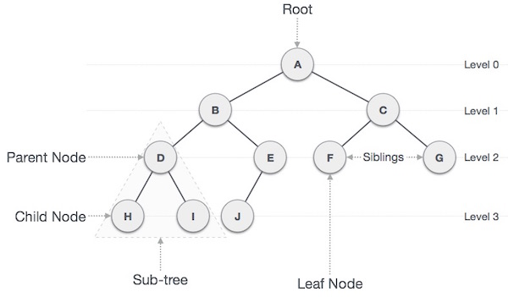

**Important Terms**

Following are the important terms with respect to tree.

* **Path** − Path refers to the sequence of nodes along the edges of a tree.
* **Root** − The node at the top of the tree is called root. There is only one root per tree and one path from the root node to any node.
* **Parent** − Any node except the root node has one edge upward to a node called parent.
* **Child** − The node below a given node connected by its edge downward is called its child node.
* **Leaf** − The node which does not have any child node is called the leaf node.
* **Subtree** − Subtree represents the descendants of a node.
* **Visiting** − Visiting refers to checking the value of a node when control is on the node.
* **Traversing** − Traversing means passing through nodes in a specific order.
* **Levels** − Level of a node represents the generation of a node. If the root node is at level 0, then its next child node is at level 1, its grandchild is at level 2, and so on.
* **keys** − Key represents a value of a node based on which a search operation is to be carried out for a node.

**Binary Search Tree Representation**

Binary Search tree exhibits a special behavior. A node's left child must have a value less than its parent's value and the node's right child must have a value greater than its parent value.

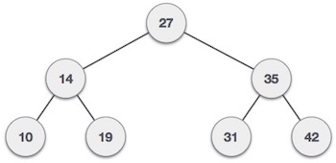

We're going to implement tree using node object and connecting them through references.

**Tree Node**

The code to write a tree node would be similar to what is given below. It has a data part and references to its left and right child nodes.

struct node {

int data;

struct node *leftChild;

struct node *rightChild;

};

In a tree, all nodes share common construct.

**BST Basic Operations**

The basic operations that can be performed on a binary search tree data structure, are the following −

* **Insert** − Inserts an element in a tree/create a tree.
* **Search** − Searches an element in a tree.
* **Preorder Traversal** − Traverses a tree in a pre-order manner.
* **Inorder Traversal** − Traverses a tree in an in-order manner.
* **Postorder Traversal** − Traverses a tree in a post-order manner.

We shall learn creating (inserting into) a tree structure and searching a data item in a tree in this chapter. We shall learn about tree traversing methods in the coming chapter.

**Insert Operation**

The very first insertion creates the tree. Afterwards, whenever an element is to be inserted, first locate its proper location. Start searching from the root node, then if the data is less than the key value, search for the empty location in the left subtree and insert the data. Otherwise, search for the empty location in the right subtree and insert the data.

**Algorithm**

If root is NULL

then create root node

return

If root exists then

compare the data with node.data

while until insertion position is located

If data is greater than node.data

goto right subtree

else

goto left subtree

endwhile

insert data

end If

**Implementation**

The implementation of insert function should look like this −

void insert(int data) {

struct node *tempNode = (struct node*) malloc(sizeof(struct node));

struct node *current;

struct node *parent;

tempNode->data = data;

tempNode->leftChild = NULL;

tempNode->rightChild = NULL;

//if tree is empty, create root node

if(root == NULL) {

root = tempNode;

} else {

current = root;

parent = NULL;

while(1) {

parent = current;

//go to left of the tree

if(data < parent->data) {

current = current->leftChild;

//insert to the left

if(current == NULL) {

parent->leftChild = tempNode;

return;

}

}

//go to right of the tree

else {

current = current->rightChild;

//insert to the right

if(current == NULL) {

parent->rightChild = tempNode;

return;

}

}

}

}

}

**Search Operation**

Whenever an element is to be searched, start searching from the root node, then if the data is less than the key value, search for the element in the left subtree. Otherwise, search for the element in the right subtree. Follow the same algorithm for each node.

**Algorithm**

If root.data is equal to search.data

return root

else

while data not found

If data is greater than node.data

goto right subtree

else

goto left subtree

If data found

return node

endwhile

return data not found

end if

The implementation of this algorithm should look like this.

struct node* search(int data) {

struct node *current = root;

printf("Visiting elements: ");

while(current->data != data) {

if(current != NULL)

printf("%d ",current->data);

//go to left tree

if(current->data > data) {

current = current->leftChild;

}

//else go to right tree

else {

current = current->rightChild;

}

//not found

if(current == NULL) {

return NULL;

}

return current;

}

}

**Tree Traversal**

Traversal is a process to visit all the nodes of a tree and may print their values too. Because, all nodes are connected via edges (links) we always start from the root (head) node. That is, we cannot randomly access a node in a tree. There are three ways which we use to traverse a tree −

* In-order Traversal
* Pre-order Traversal
* Post-order Traversal

Generally, we traverse a tree to search or locate a given item or key in the tree or to print all the values it contains.

**In-order Traversal**

In this traversal method, the left subtree is visited first, then the root and later the right sub-tree. We should always remember that every node may represent a subtree itself.

If a binary tree is traversed **in-order**, the output will produce sorted key values in an ascending order.

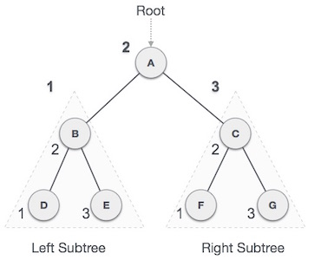

We start from **A**, and following in-order traversal, we move to its left subtree **B**. **B** is also traversed in-order. The process goes on until all the nodes are visited. The output of inorder traversal of this tree will be −

***D → B → E → A → F → C → G***

**Algorithm**

Until all nodes are traversed −

**Step 1** − Recursively traverse left subtree.

**Step 2** − Visit root node.

**Step 3** − Recursively traverse right subtree.

**Pre-order Traversal**

In this traversal method, the root node is visited first, then the left subtree and finally the right subtree.

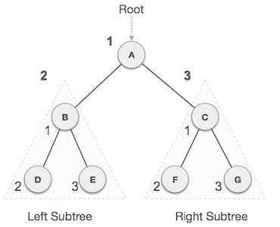

We start from **A**, and following pre-order traversal, we first visit **A** itself and then move to its left subtree **B**. **B** is also traversed pre-order. The process goes on until all the nodes are visited. The output of pre-order traversal of this tree will be −

***A → B → D → E → C → F → G***

**Algorithm**

Until all nodes are traversed −

**Step 1** − Visit root node.

**Step 2** − Recursively traverse left subtree.

**Step 3** − Recursively traverse right subtree.

**Post-order Traversal**

In this traversal method, the root node is visited last, hence the name. First we traverse the left subtree, then the right subtree and finally the root node.

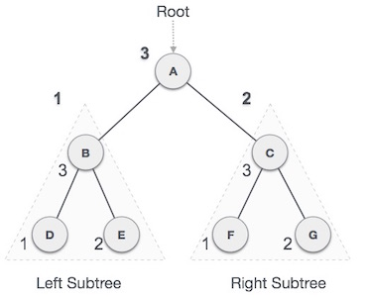

We start from **A**, and following pre-order traversal, we first visit the left subtree **B**. **B** is also traversed post-order. The process goes on until all the nodes are visited. The output of post-order traversal of this tree will be −

***D → E → B → F → G → C → A***

**Algorithm**

Until all nodes are traversed −

**Step 1** − Recursively traverse left subtree.

**Step 2** − Recursively traverse right subtree.

**Step 3** − Visit root node.

Traversal is a process to visit all the nodes of a tree and may print their values too. Because, all nodes are connected via edges (links) we always start from the root (head) node. That is, we cannot random access a node in a tree. There are three ways which we use to traverse a tree −

* In-order Traversal
* Pre-order Traversal
* Post-order Traversal

We shall now look at the implementation of tree traversal in C programming language here using the following binary tree −



Implementation in C

#include <stdio.h>

#include <stdlib.h>

struct node {

int data;

struct node *leftChild;

struct node *rightChild;

};

struct node *root = NULL;

void insert(int data) {

struct node *tempNode = (struct node*) malloc(sizeof(struct node));

struct node *current;

struct node *parent;

tempNode->data = data;

tempNode->leftChild = NULL;

tempNode->rightChild = NULL;

//if tree is empty

if(root == NULL) {

root = tempNode;

} else {

current = root;

parent = NULL;

while(1) {

parent = current;

//go to left of the tree

if(data < parent->data) {

current = current->leftChild;

//insert to the left

if(current == NULL) {

parent->leftChild = tempNode;

return;

}

}//go to right of the tree

else {

current = current->rightChild;

//insert to the right

if(current == NULL) {

parent->rightChild = tempNode;

return;

}

}

}

}

}

struct node* search(int data) {

struct node *current = root;

printf("Visiting elements: ");

while(current->data != data) {

if(current != NULL)

printf("%d ",current->data);

//go to left tree

if(current->data > data) {

current = current->leftChild;

}

//else go to right tree

else {

current = current->rightChild;

}

//not found

if(current == NULL) {

return NULL;

}

}

return current;

}

void **pre_order_traversal**(struct node* root) {

if(root != NULL) {

printf("%d ",root->data);

pre_order_traversal(root->leftChild);

pre_order_traversal(root->rightChild);

}

}

void **inorder_traversal**(struct node* root) {

if(root != NULL) {

inorder_traversal(root->leftChild);

printf("%d ",root->data);

inorder_traversal(root->rightChild);

}

}

void **post_order_traversal**(struct node* root) {

if(root != NULL) {

post_order_traversal(root->leftChild);

post_order_traversal(root->rightChild);

printf("%d ", root->data);

}

}

int main() {

int i;

int array[7] = { 27, 14, 35, 10, 19, 31, 42 };

for(i = 0; i < 7; i++)

insert(array[i]);

i = 31;

struct node * temp = search(i);

if(temp != NULL) {

printf("[%d] Element found.", temp->data);

printf("\n");

}else {

printf("[ x ] Element not found (%d).\n", i);

}

i = 15;

temp = search(i);

if(temp != NULL) {

printf("[%d] Element found.", temp->data);

printf("\n");

}else {

printf("[ x ] Element not found (%d).\n", i);

}

printf("\nPreorder traversal: ");

pre_order_traversal(root);

printf("\nInorder traversal: ");

inorder_traversal(root);

printf("\nPost order traversal: ");

post_order_traversal(root);

return 0;

}

If we compile and run the above program, it will produce the following result −

Output

**Lesson Twenty: AVL Trees**

What if the input to binary search tree comes in a sorted (ascending or descending) manner? It will then look like this −

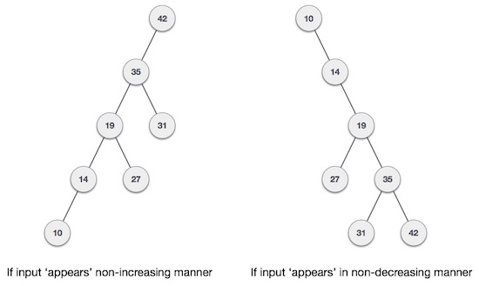

It is observed that BST's worst-case performance is closest to linear search algorithms, that is Ο(n). In real-time data, we cannot predict data pattern and their frequencies. So, a need arises to balance out the existing BST.

Named after their inventor **Adelson**, **Velski** & **Landis**, **AVL trees** are height balancing binary search tree. AVL tree checks the height of the left and the right sub-trees and assures that the difference is not more than 1. This difference is called the **Balance Factor**.

Here we see that the first tree is balanced and the next two trees are not balanced −

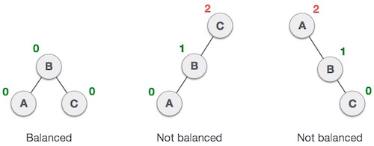

In the second tree, the left subtree of **C** has height 2 and the right subtree has height 0, so the difference is 2. In the third tree, the right subtree of **A** has height 2 and the left is missing, so it is 0, and the difference is 2 again. AVL tree permits difference (balance factor) to be only 1.

***BalanceFactor*** = height(left-sutree) − height(right-sutree)

If the difference in the height of left and right sub-trees is more than 1, the tree is balanced using some rotation techniques.

**AVL Rotations**

To balance itself, an AVL tree may perform the following four kinds of rotations −

* Left rotation
* Right rotation
* Left-Right rotation
* Right-Left rotation

The first two rotations are single rotations and the next two rotations are double rotations. To have an unbalanced tree, we at least need a tree of height 2. With this simple tree, let's understand them one by one.

**Left Rotation**

If a tree becomes unbalanced, when a node is inserted into the right subtree of the right subtree, then we perform a single left rotation −

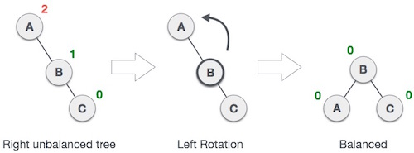

In our example, node **A** has become unbalanced as a node is inserted in the right subtree of A's right subtree. We perform the left rotation by making **A** the left-subtree of B.

**Right Rotation**

AVL tree may become unbalanced, if a node is inserted in the left subtree of the left subtree. The tree then needs a right rotation.

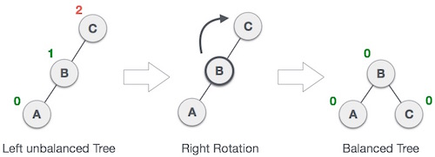

As depicted, the unbalanced node becomes the right child of its left child by performing a right rotation.

**Left-Right Rotation**

Double rotations are slightly complex version of already explained versions of rotations. To understand them better, we should take note of each action performed while rotation. Let's first check how to perform Left-Right rotation. A left-right rotation is a combination of left rotation followed by right rotation.

|  |  |
| --- | --- |
| **State** | **Action** |
| Right Rotation | A node has been inserted into the right subtree of the left subtree. This makes **C** an unbalanced node. These scenarios cause AVL tree to perform left-right rotation. |
| Left Rotation | We first perform the left rotation on the left subtree of **C**. This makes **A**, the left subtree of **B**. |
| Left Rotation | Node **C** is still unbalanced, however now, it is because of the left-subtree of the left-subtree. |
| Right Rotation | We shall now right-rotate the tree, making **B** the new root node of this subtree. **C** now becomes the right subtree of its own left subtree. |
| Balanced Avl Tree | The tree is now balanced. |

**Right-Left Rotation**

The second type of double rotation is Right-Left Rotation. It is a combination of right rotation followed by left rotation.

|  |  |
| --- | --- |
| **State** | **Action** |
| Left Subtree of Right Subtree | A node has been inserted into the left subtree of the right subtree. This makes **A**, an unbalanced node with balance factor 2. |
| Subtree Right Rotation | First, we perform the right rotation along **C** node, making **C** the right subtree of its own left subtree **B**. Now, **B** becomes the right subtree of **A**. |
| Right Unbalanced Tree | Node **A** is still unbalanced because of the right subtree of its right subtree and requires a left rotation. |
| Left Rotation | A left rotation is performed by making **B** the new root node of the subtree. **A** becomes the left subtree of its right subtree **B**. |
| Balanced AVL Tree | The tree is now balanced. |

**Lesson Twenty One: Heap Data Structures**

Heap is a special case of balanced binary tree data structure where the root-node key is compared with its children and arranged accordingly. If **α** has child node **β** then −

**key(α) ≥ key(β)**

As the value of parent is greater than that of child, this property generates **Max Heap**. Based on this criteria, a heap can be of two types −

For Input → 35 33 42 10 14 19 27 44 26 31

**Min-Heap** − Where the value of the root node is less than or equal to either of its children.

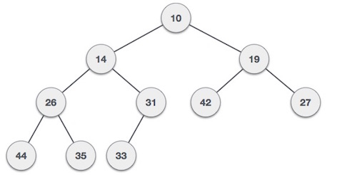

**Max-Heap** − Where the value of the root node is greater than or equal to either of its children.

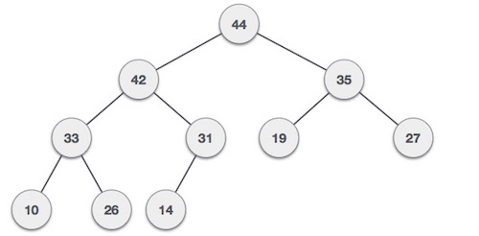

Both trees are constructed using the same input and order of arrival.

**Max Heap Construction Algorithm**

We shall use the same example to demonstrate how a Max Heap is created. The procedure to create Min Heap is similar but we go for min values instead of max values.

We are going to derive an algorithm for max heap by inserting one element at a time. At any point of time, heap must maintain its property. While insertion, we also assume that we are inserting a node in an already heapified tree.

**Step 1** − Create a new node at the end of heap.

**Step 2** − Assign new value to the node.

**Step 3** − Compare the value of this child node with its parent.

**Step 4** − If value of parent is less than child, then swap them.

**Step 5** − Repeat step 3 & 4 until Heap property holds.

**Note** − In Min Heap construction algorithm, we expect the value of the parent node to be less than that of the child node.

Let's understand Max Heap construction by an animated illustration. We consider the same input sample that we used earlier.



**Max Heap Deletion Algorithm**

Let us derive an algorithm to delete from max heap. Deletion in Max (or Min) Heap always happens at the root to remove the Maximum (or minimum) value.

**Step 1** − Remove root node.

**Step 2** − Move the last element of last level to root.

**Step 3** − Compare the value of this child node with its parent.

**Step 4** − If value of parent is less than child, then swap them.

**Step 5** − Repeat step 3 & 4 until Heap property holds.



**Lesson Seven: Linear Search**

Linear search is a very simple search algorithm. In this type of search, a sequential search is made over all items one by one. Every item is checked and if a match is found then that particular item is returned, otherwise the search continues till the end of the data collection.



**Algorithm**

Linear Search ( Array A, Value x)

Step 1: Set i to 1

Step 2: if i > n then go to step 7

Step 3: if A[i] = x then go to step 6

Step 4: Set i to i + 1

Step 5: Go to Step 2

Step 6: Print Element x Found at index i and go to step 8

Step 7: Print element not found

Step 8: Exit

**Pseudocode**

procedure linear_search (list, value)

for each item in the list

if match item == value

return the item's location

end if

end for

end procedure

Here we present the implementation of linear search in C programming language. The output of the program is given after the code.

Linear Search Program

#include <stdio.h>

#define MAX 20

// array of items on which linear search will be conducted.

int intArray[MAX] = {1,2,3,4,6,7,9,11,12,14,15,16,17,19,33,34,43,45,55,66};

void printline(int count) {

int i;

for(i = 0;i <count-1;i++) {

printf("=");

}

printf("=\n");

}

// this method makes a linear search.

int find(int data) {

int comparisons = 0;

int index = -1;

int i;

// navigate through all items

for(i = 0;i<MAX;i++) {

// count the comparisons made

comparisons++;

// if data found, break the loop

if(data == intArray[i]) {

index = i;

break;

}

}

printf("Total comparisons made: %d", comparisons);

return index;

}

void display() {

int i;

printf("[");

// navigate through all items

for(i = 0;i<MAX;i++) {

printf("%d ",intArray[i]);

}

printf("]\n");

}

main() {

printf("Input Array: ");

display();

printline(50);

//find location of 1

int location = find(55);

// if element was found

if(location != -1)

printf("\nElement found at location: %d" ,(location+1));

else

printf("Element not found.");

}

If we compile and run the above program, it will produce the following result −

Output

Input Array: [1 2 3 4 6 7 9 11 12 14 15 16 17 19 33 34 43 45 55 66 ]

==================================================

Total comparisons made: 19

Element found at location: 19

**Lesson Eight: Binary Search**

Binary search is a fast search algorithm with run-time complexity of Ο(log n). This search algorithm works on the principle of divide and conquer. For this algorithm to work properly, the data collection should be in the sorted form.

Binary search looks for a particular item by comparing the middle most item of the collection. If a match occurs, then the index of item is returned. If the middle item is greater than the item, then the item is searched in the sub-array to the left of the middle item. Otherwise, the item is searched for in the sub-array to the right of the middle item. This process continues on the sub-array as well until the size of the subarray reduces to zero.

**How Binary Search Works?**

For a binary search to work, it is mandatory for the target array to be sorted. We shall learn the process of binary search with a pictorial example. The following is our sorted array and let us assume that we need to search the location of value 31 using binary search.

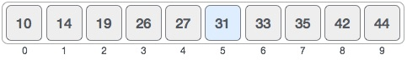

First, we shall determine half of the array by using this formula −

mid = low + (high - low) / 2

Here it is, 0 + (9 - 0 ) / 2 = 4 (integer value of 4.5). So, 4 is the mid of the array.

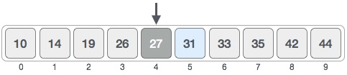

Now we compare the value stored at location 4, with the value being searched, i.e. 31. We find that the value at location 4 is 27, which is not a match. As the value is greater than 27 and we have a sorted array, so we also know that the target value must be in the upper portion of the array.

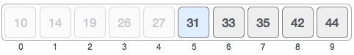

We change our low to mid + 1 and find the new mid value again.

low = mid + 1

mid = low + (high - low) / 2

Our new mid is 7 now. We compare the value stored at location 7 with our target value 31.

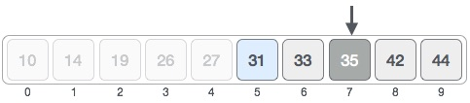

The value stored at location 7 is not a match, rather it is less than what we are looking for. So, the value must be in the lower part from this location.

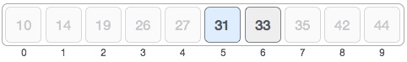

Hence, we calculate the mid again. This time it is 5.

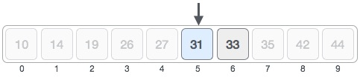

We compare the value stored at location 5 with our target value. We find that it is a match.

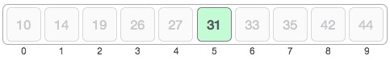

We conclude that the target value 31 is stored at location 5.

Binary search halves the searchable items and thus reduces the count of comparisons to be made to very less numbers.

**Pseudocode**

The pseudocode of binary search algorithms should look like this −

Procedure binary_search

A ← sorted array

n ← size of array

x ← value to be searched

Set lowerBound = 1

Set upperBound = n

while x not found

if upperBound < lowerBound

EXIT: x does not exists.

set midPoint = lowerBound + ( upperBound - lowerBound ) / 2

if A[midPoint] < x

set lowerBound = midPoint + 1

if A[midPoint] > x

set upperBound = midPoint - 1

if A[midPoint] = x

EXIT: x found at location midPoint

end while

end procedure

Binary search is a fast search algorithm with run-time complexity of Ο(log n). This search algorithm works on the principle of divide and conquer. For this algorithm to work properly, the data collection should be in a sorted form.

Implementation in C

#include <stdio.h>

#define MAX 20

// array of items on which linear search will be conducted.

int intArray[MAX] = {1,2,3,4,6,7,9,11,12,14,15,16,17,19,33,34,43,45,55,66};

void printline(int count) {

int i;

for(i = 0;i <count-1;i++) {

printf("=");

}

printf("=\n");

}

int find(int data) {

int lowerBound = 0;

int upperBound = MAX -1;

int midPoint = -1;

int comparisons = 0;

int index = -1;

while(lowerBound <= upperBound) {

printf("Comparison %d\n" , (comparisons +1) );

printf("lowerBound : %d, intArray[%d] = %d\n",lowerBound,lowerBound,

intArray[lowerBound]);

printf("upperBound : %d, intArray[%d] = %d\n",upperBound,upperBound,

intArray[upperBound]);

comparisons++;

// compute the mid point

// midPoint = (lowerBound + upperBound) / 2;

midPoint = lowerBound + (upperBound - lowerBound) / 2;

// data found

if(intArray[midPoint] == data) {

index = midPoint;

break;

} else {

// if data is larger

if(intArray[midPoint] < data) {

// data is in upper half

lowerBound = midPoint + 1;

}

// data is smaller

else {

// data is in lower half

upperBound = midPoint -1;

}

}

}

printf("Total comparisons made: %d" , comparisons);

return index;

}

void display() {

int i;

printf("[");

// navigate through all items

for(i = 0;i<MAX;i++) {

printf("%d ",intArray[i]);

}

printf("]\n");

}

main() {

printf("Input Array: ");

display();

printline(50);

//find location of 1

int location = find(55);

// if element was found

if(location != -1)

printf("\nElement found at location: %d" ,(location+1));

else

printf("\nElement not found.");

}

If we compile and run the above program then it would produce following result −

Output

Input Array: [1 2 3 4 6 7 9 11 12 14 15 16 17 19 33 34 43 45 55 66 ]

==================================================

Comparison 1

lowerBound : 0, intArray[0] = 1

upperBound : 19, intArray[19] = 66

Comparison 2

lowerBound : 10, intArray[10] = 15

upperBound : 19, intArray[19] = 66

Comparison 3

lowerBound : 15, intArray[15] = 34

upperBound : 19, intArray[19] = 66

Comparison 4

lowerBound : 18, intArray[18] = 55

upperBound : 19, intArray[19] = 66

Total comparisons made: 4

Element found at location: 19

**Lesson Nine: Interpolation Search**

Interpolation search is an improved variant of binary search. This search algorithm works on the probing position of the required value. For this algorithm to work properly, the data collection should be in a sorted form and equally distributed.

Binary search has a huge advantage of time complexity over linear search. Linear search has worst-case complexity of Ο(n) whereas binary search has Ο(log n).

There are cases where the location of target data may be known in advance. For example, in case of a telephone directory, if we want to search the telephone number of Morphius. Here, linear search and even binary search will seem slow as we can directly jump to memory space where the names start from 'M' are stored.

**Positioning in Binary Search**

In binary search, if the desired data is not found then the rest of the list is divided in two parts, lower and higher. The search is carried out in either of them.

BST Step OneBST Step TwoBST Step ThreeBST Step Four

Even when the data is sorted, binary search does not take advantage to probe the position of the desired data.

**Position Probing in Interpolation Search**

Interpolation search finds a particular item by computing the probe position. Initially, the probe position is the position of the middle most item of the collection.

Interpolation Step OneInterpolation Step Two

If a match occurs, then the index of the item is returned. To split the list into two parts, we use the following method −

mid = Lo + ((Hi - Lo) / (A[Hi] - A[Lo])) * (X - A[Lo])

where −

A = list

Lo = Lowest index of the list

Hi = Highest index of the list

A[n] = Value stored at index n in the list

If the middle item is greater than the item, then the probe position is again calculated in the sub-array to the right of the middle item. Otherwise, the item is searched in the subarray to the left of the middle item. This process continues on the sub-array as well until the size of subarray reduces to zero.

Runtime complexity of interpolation search algorithm is **Ο(log (log n))** as compared to **Ο(log n)** of BST in favorable situations.

**Algorithm**

As it is an improvisation of the existing BST algorithm, we are mentioning the steps to search the 'target' data value index, using position probing −

Step 1 − Start searching **data** from middle of the list.

Step 2 − If it is a match, return the index of the item, and exit.

Step 3 − If it is not a match, probe position.

Step 4 − Divide the list using probing formula and find the new midle.

Step 5 − If data is greater than middle, search in higher sub-list.

Step 6 − If data is smaller than middle, search in lower sub-list.

Step 7 − Repeat until match.

**Pseudocode**

A → Array list

N → Size of A

X → Target Value

Procedure Interpolation_Search()

Set Lo → 0

Set Mid → -1

Set Hi → N-1

While X does not match

if Lo equals to Hi OR A[Lo] equals to A[Hi]

EXIT: Failure, Target not found

end if

Set Mid = Lo + ((Hi - Lo) / (A[Hi] - A[Lo])) * (X - A[Lo])

if A[Mid] = X

EXIT: Success, Target found at Mid

else

if A[Mid] < X

Set Lo to Mid+1

else if A[Mid] > X

Set Hi to Mid-1

end if

end if

End While

End Procedure

Interpolation search is an improved variant of binary search. This search algorithm works on the probing position of the required value. For this algorithm to work properly, the data collection should be in sorted and equally distributed form.

It's runtime complexity is **log2(log2 n)**.

Implementation in C

#include<stdio.h>

#define MAX 10

// array of items on which linear search will be conducted.

int list[MAX] = { 10, 14, 19, 26, 27, 31, 33, 35, 42, 44 };

int find(int data) {

int lo = 0;

int hi = MAX - 1;

int mid = -1;

int comparisons = 1;

int index = -1;

while(lo <= hi) {

printf("\nComparison %d \n" , comparisons ) ;

printf("lo : %d, list[%d] = %d\n", lo, lo, list[lo]);

printf("hi : %d, list[%d] = %d\n", hi, hi, list[hi]);

comparisons++;

// probe the mid point

mid = lo + (((double)(hi - lo) / (list[hi] - list[lo])) * (data - list[lo]));

printf("mid = %d\n",mid);

// data found

if(list[mid] == data) {

index = mid;

break;

} else {

if(list[mid] < data) {

// if data is larger, data is in upper half

lo = mid + 1;

} else {

// if data is smaller, data is in lower half

hi = mid - 1;

}

}

}

printf("\nTotal comparisons made: %d", --comparisons);

return index;

}

int main() {

//find location of 33

int location = find(33);

// if element was found

if(location != -1)

printf("\nElement found at location: %d" ,(location+1));

else

printf("Element not found.");

return 0;

}

If we compile and run the above program, it will produce the following result −

Output

Comparison 1

lo : 0, list[0] = 10

hi : 9, list[9] = 44

mid = 6

Total comparisons made: 1

Element found at location: 7

You can change the search value and execute the program to test it.

**Lesson Eleven: Sorting Techniques**

Sorting refers to arranging data in a particular format. Sorting algorithm specifies the way to arrange data in a particular order. Most common orders are in numerical or lexicographical order.

The importance of sorting lies in the fact that data searching can be optimized to a very high level, if data is stored in a sorted manner. Sorting is also used to represent data in more readable formats. Following are some of the examples of sorting in real-life scenarios −

* **Telephone Directory** − The telephone directory stores the telephone numbers of people sorted by their names, so that the names can be searched easily.
* **Dictionary** − The dictionary stores words in an alphabetical order so that searching of any word becomes easy.

**In-place Sorting and Not-in-place Sorting**

Sorting algorithms may require some extra space for comparison and temporary storage of few data elements. These algorithms do not require any extra space and sorting is said to happen in-place, or for example, within the array itself. This is called **in-place sorting**. Bubble sort is an example of in-place sorting.

However, in some sorting algorithms, the program requires space which is more than or equal to the elements being sorted. Sorting which uses equal or more space is called **not-in-place sorting**. Merge-sort is an example of not-in-place sorting.

**Stable and Not Stable Sorting**

If a sorting algorithm, after sorting the contents, does not change the sequence of similar content in which they appear, it is called **stable sorting**.

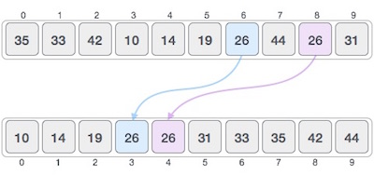

If a sorting algorithm, after sorting the contents, changes the sequence of similar content in which they appear, it is called **unstable sorting**.

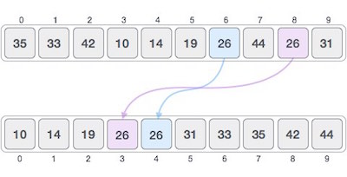

Stability of an algorithm matters when we wish to maintain the sequence of original elements, like in a tuple for example.

**Adaptive and Non-Adaptive Sorting Algorithm**

A sorting algorithm is said to be adaptive, if it takes advantage of already 'sorted' elements in the list that is to be sorted. That is, while sorting if the source list has some element already sorted, adaptive algorithms will take this into account and will try not to re-order them.

A non-adaptive algorithm is one which does not take into account the elements which are already sorted. They try to force every single element to be re-ordered to confirm their sortedness.

**Important Terms**

Some terms are generally coined while discussing sorting techniques, here is a brief introduction to them −

**Increasing Order**

A sequence of values is said to be in **increasing order**, if the successive element is greater than the previous one. For example, 1, 3, 4, 6, 8, 9 are in increasing order, as every next element is greater than the previous element.

**Decreasing Order**

A sequence of values is said to be in **decreasing order**, if the successive element is less than the current one. For example, 9, 8, 6, 4, 3, 1 are in decreasing order, as every next element is less than the previous element.

**Non-Increasing Order**

A sequence of values is said to be in **non-increasing order**, if the successive element is less than or equal to its previous element in the sequence. This order occurs when the sequence contains duplicate values. For example, 9, 8, 6, 3, 3, 1 are in non-increasing order, as every next element is less than or equal to (in case of 3) but not greater than any previous element.

**Non-Decreasing Order**

A sequence of values is said to be in **non-decreasing order**, if the successive element is greater than or equal to its previous element in the sequence. This order occurs when the sequence contains duplicate values. For example, 1, 3, 3, 6, 8, 9 are in non-decreasing order, as every next element is greater than or equal to (in case of 3) but not less than the previous one.

**Lesson Twelve: Bubble Sort Algorithm**

Bubble sort is a simple sorting algorithm. This sorting algorithm is comparison-based algorithm in which each pair of adjacent elements is compared and the elements are swapped if they are not in order. This algorithm is not suitable for large data sets as its average and worst case complexity are of Ο(n2) where **n** is the number of items.

**How Bubble Sort Works?**

We take an unsorted array for our example. Bubble sort takes Ο(n2) time so we're keeping it short and precise.

Bubble Sort

Bubble sort starts with very first two elements, comparing them to check which one is greater.

Bubble Sort

In this case, value 33 is greater than 14, so it is already in sorted locations. Next, we compare 33 with 27.

Bubble Sort

We find that 27 is smaller than 33 and these two values must be swapped.

Bubble Sort

The new array should look like this −

Bubble Sort

Next we compare 33 and 35. We find that both are in already sorted positions.

Bubble Sort

Then we move to the next two values, 35 and 10.

Bubble Sort

We know then that 10 is smaller 35. Hence they are not sorted.

Bubble Sort

We swap these values. We find that we have reached the end of the array. After one iteration, the array should look like this −

Bubble Sort

To be precise, we are now showing how an array should look like after each iteration. After the second iteration, it should look like this −

Bubble Sort

Notice that after each iteration, at least one value moves at the end.

Bubble Sort

And when there's no swap required, bubble sorts learns that an array is completely sorted.

Bubble Sort

Now we should look into some practical aspects of bubble sort.

**Algorithm**

We assume **list** is an array of **n** elements. We further assume that **swap** function swaps the values of the given array elements.

begin BubbleSort(list)

for all elements of list

if list[i] > list[i+1]

swap(list[i], list[i+1])

end if

end for

return list

end BubbleSort

**Pseudocode**

We observe in algorithm that Bubble Sort compares each pair of array element unless the whole array is completely sorted in an ascending order. This may cause a few complexity issues like what if the array needs no more swapping as all the elements are already ascending.

To ease-out the issue, we use one flag variable **swapped** which will help us see if any swap has happened or not. If no swap has occurred, i.e. the array requires no more processing to be sorted, it will come out of the loop.

Pseudocode of BubbleSort algorithm can be written as follows −

procedure bubbleSort( list : array of items )

loop = list.count;

for i = 0 to loop-1 do:

swapped = false

for j = 0 to loop-1 do:

/* compare the adjacent elements */

if list[j] > list[j+1] then

/* swap them */

swap( list[j], list[j+1] )

swapped = true

end if

end for

/*if no number was swapped that means

array is sorted now, break the loop.*/

if(not swapped) then

break

end if

end for

end procedure return list

**Implementation**

One more issue we did not address in our original algorithm and its improvised pseudocode, is that, after every iteration the highest values settles down at the end of the array. Hence, the next iteration need not include already sorted elements. For this purpose, in our implementation, we restrict the inner loop to avoid already sorted values.

We shall see the implementation of **bubble sort** in C programming language here.

Implementation in C

#include <stdio.h>

#include <stdbool.h>

#define MAX 10

int list[MAX] = {1,8,4,6,0,3,5,2,7,9};

void display() {

int i;

printf("[");

// navigate through all items

for(i = 0; i < MAX; i++) {

printf("%d ",list[i]);

}

printf("]\n");

}

void bubbleSort() {

int temp;

int i,j;

bool swapped = false;

// loop through all numbers

for(i = 0; i < MAX-1; i++) {

swapped = false;

// loop through numbers falling ahead

for(j = 0; j < MAX-1-i; j++) {

printf(" Items compared: [ %d, %d ] ", list[j],list[j+1]);

// check if next number is lesser than current no

// swap the numbers.

// (Bubble up the highest number)

if(list[j] > list[j+1]) {

temp = list[j];

list[j] = list[j+1];

list[j+1] = temp;

swapped = true;

printf(" => swapped [%d, %d]\n",list[j],list[j+1]);

}else {

printf(" => not swapped\n");

}

}

// if no number was swapped that means

// array is sorted now, break the loop.

if(!swapped) {

break;

}

printf("Iteration %d#: ",(i+1));

display();

}

}

main() {

printf("Input Array: ");

display();

printf("\n");

bubbleSort();

printf("\nOutput Array: ");

display();

}

If we compile and run the above program, it will produce the following result −

Output

Input Array: [1 8 4 6 0 3 5 2 7 9 ]

Items compared: [ 1, 8 ] => not swapped

Items compared: [ 8, 4 ] => swapped [4, 8]

Items compared: [ 8, 6 ] => swapped [6, 8]

Items compared: [ 8, 0 ] => swapped [0, 8]

Items compared: [ 8, 3 ] => swapped [3, 8]

Items compared: [ 8, 5 ] => swapped [5, 8]

Items compared: [ 8, 2 ] => swapped [2, 8]

Items compared: [ 8, 7 ] => swapped [7, 8]

Items compared: [ 8, 9 ] => not swapped

Iteration 1#: [1 4 6 0 3 5 2 7 8 9 ]

Items compared: [ 1, 4 ] => not swapped

Items compared: [ 4, 6 ] => not swapped

Items compared: [ 6, 0 ] => swapped [0, 6]

Items compared: [ 6, 3 ] => swapped [3, 6]

Items compared: [ 6, 5 ] => swapped [5, 6]

Items compared: [ 6, 2 ] => swapped [2, 6]

Items compared: [ 6, 7 ] => not swapped

Items compared: [ 7, 8 ] => not swapped

Iteration 2#: [1 4 0 3 5 2 6 7 8 9 ]

Items compared: [ 1, 4 ] => not swapped

Items compared: [ 4, 0 ] => swapped [0, 4]

Items compared: [ 4, 3 ] => swapped [3, 4]

Items compared: [ 4, 5 ] => not swapped

Items compared: [ 5, 2 ] => swapped [2, 5]

Items compared: [ 5, 6 ] => not swapped

Items compared: [ 6, 7 ] => not swapped

Iteration 3#: [1 0 3 4 2 5 6 7 8 9 ]

Items compared: [ 1, 0 ] => swapped [0, 1]

Items compared: [ 1, 3 ] => not swapped

Items compared: [ 3, 4 ] => not swapped

Items compared: [ 4, 2 ] => swapped [2, 4]

Items compared: [ 4, 5 ] => not swapped

Items compared: [ 5, 6 ] => not swapped

Iteration 4#: [0 1 3 2 4 5 6 7 8 9 ]

Items compared: [ 0, 1 ] => not swapped

Items compared: [ 1, 3 ] => not swapped

Items compared: [ 3, 2 ] => swapped [2, 3]

Items compared: [ 3, 4 ] => not swapped

Items compared: [ 4, 5 ] => not swapped

Iteration 5#: [0 1 2 3 4 5 6 7 8 9 ]

Items compared: [ 0, 1 ] => not swapped

Items compared: [ 1, 2 ] => not swapped

Items compared: [ 2, 3 ] => not swapped

Items compared: [ 3, 4 ] => not swapped

Output Array: [0 1 2 3 4 5 6 7 8 9 ]

**Lesson Thirteen: Insertion Sort**

This is an in-place comparison-based sorting algorithm. Here, a sub-list is maintained which is always sorted. For example, the lower part of an array is maintained to be sorted. An element which is to be 'insert'ed in this sorted sub-list, has to find its appropriate place and then it has to be inserted there. Hence the name, **insertion sort**.

The array is searched sequentially and unsorted items are moved and inserted into the sorted sub-list (in the same array). This algorithm is not suitable for large data sets as its average and worst case complexity are of Ο(n2), where **n** is the number of items.

**How Insertion Sort Works?**

We take an unsorted array for our example.

Unsorted Array

Insertion sort compares the first two elements.

Insertion Sort

It finds that both 14 and 33 are already in ascending order. For now, 14 is in sorted sub-list.

Insertion Sort

Insertion sort moves ahead and compares 33 with 27.

Insertion Sort

And finds that 33 is not in the correct position.

Insertion Sort

It swaps 33 with 27. It also checks with all the elements of sorted sub-list. Here we see that the sorted sub-list has only one element 14, and 27 is greater than 14. Hence, the sorted sub-list remains sorted after swapping.

Insertion Sort

By now we have 14 and 27 in the sorted sub-list. Next, it compares 33 with 10.

Insertion Sort

These values are not in a sorted order.

Insertion Sort

So we swap them.

Insertion Sort

However, swapping makes 27 and 10 unsorted.

Insertion Sort

Hence, we swap them too.

Insertion Sort

Again we find 14 and 10 in an unsorted order.

Insertion Sort

We swap them again. By the end of third iteration, we have a sorted sub-list of 4 items.

Insertion Sort

This process goes on until all the unsorted values are covered in a sorted sub-list. Now we shall see some programming aspects of insertion sort.

**Algorithm**

Now we have a bigger picture of how this sorting technique works, so we can derive simple steps by which we can achieve insertion sort.

**Step 1** − If it is the first element, it is already sorted. return 1;

**Step 2** − Pick next element

**Step 3** − Compare with all elements in the sorted sub-list

**Step 4** − Shift all the elements in the sorted sub-list that is greater than the

value to be sorted

**Step 5** − Insert the value

**Step 6** − Repeat until list is sorted

**Pseudocode**

procedure insertionSort( A : array of items )

int holePosition

int valueToInsert

for i = 1 to length(A) inclusive do:

/* select value to be inserted */

valueToInsert = A[i]

holePosition = i

/*locate hole position for the element to be inserted */

while holePosition > 0 and A[holePosition-1] > valueToInsert do:

A[holePosition] = A[holePosition-1]

holePosition = holePosition -1

end while

/* insert the number at hole position */

A[holePosition] = valueToInsert

end for

end procedure

This is an in-place comparison-based sorting algorithm. Here, a sub-list is maintained which is always sorted. For example, the lower part of an array is maintained to be sorted. An element which is to be 'insert'ed in this sorted sub-list, has to find its appropriate place and then it is to be inserted there. Hence the name insertion sort.

Implementation in C

#include <stdio.h>

#include <stdbool.h>

#define MAX 7

int intArray[MAX] = {4,6,3,2,1,9,7};

void printline(int count) {

int i;

for(i = 0;i <count-1;i++) {

printf("=");

}

printf("=\n");

}

void display() {

int i;

printf("[");

// navigate through all items

for(i = 0;i<MAX;i++) {

printf("%d ",intArray[i]);

}

printf("]\n");

}

void insertionSort() {

int valueToInsert;

int holePosition;

int i;

// loop through all numbers

for(i = 1; i < MAX; i++) {

// select a value to be inserted.

valueToInsert = intArray[i];

// select the hole position where number is to be inserted

holePosition = i;

// check if previous no. is larger than value to be inserted

while (holePosition > 0 && intArray[holePosition-1] > valueToInsert) {

intArray[holePosition] = intArray[holePosition-1];

holePosition--;

printf(" item moved : %d\n" , intArray[holePosition]);

}

if(holePosition != i) {

printf(" item inserted : %d, at position : %d\n" , valueToInsert,holePosition);

// insert the number at hole position

intArray[holePosition] = valueToInsert;

}

printf("Iteration %d#:",i);

display();

}

}

main() {

printf("Input Array: ");

display();

printline(50);

insertionSort();

printf("Output Array: ");

display();

printline(50);

}

If we compile and run the above program, it will produce the following result −

Output

Input Array: [4 6 3 2 1 9 7 ]

==================================================

Iteration 1#:[4 6 3 2 1 9 7 ]

item moved : 6

item moved : 4

item inserted : 3, at position : 0

Iteration 2#:[3 4 6 2 1 9 7 ]

item moved : 6

item moved : 4

item moved : 3

item inserted : 2, at position : 0

Iteration 3#:[2 3 4 6 1 9 7 ]

item moved : 6

item moved : 4

item moved : 3

item moved : 2

item inserted : 1, at position : 0

Iteration 4#:[1 2 3 4 6 9 7 ]

Iteration 5#:[1 2 3 4 6 9 7 ]

item moved : 9

item inserted : 7, at position : 5

Iteration 6#:[1 2 3 4 6 7 9 ]

Output Array: [1 2 3 4 6 7 9 ]

**Lesson Thirteen: Selection Sort**

Selection sort is a simple sorting algorithm. This sorting algorithm is an in-place comparison-based algorithm in which the list is divided into two parts, the sorted part at the left end and the unsorted part at the right end. Initially, the sorted part is empty and the unsorted part is the entire list.

The smallest element is selected from the unsorted array and swapped with the leftmost element, and that element becomes a part of the sorted array. This process continues moving unsorted array boundary by one element to the right.

This algorithm is not suitable for large data sets as its average and worst case complexities are of Ο(n2), where **n** is the number of items.

**How Selection Sort Works?**

Consider the following depicted array as an example.

Unsorted Array

For the first position in the sorted list, the whole list is scanned sequentially. The first position where 14 is stored presently, we search the whole list and find that 10 is the lowest value.

Selection Sort

So we replace 14 with 10. After one iteration 10, which happens to be the minimum value in the list, appears in the first position of the sorted list.

Selection Sort

For the second position, where 33 is residing, we start scanning the rest of the list in a linear manner.

Selection Sort

We find that 14 is the second lowest value in the list and it should appear at the second place. We swap these values.

Selection Sort

After two iterations, two least values are positioned at the beginning in a sorted manner.

Selection Sort

The same process is applied to the rest of the items in the array.

Following is a pictorial depiction of the entire sorting process −

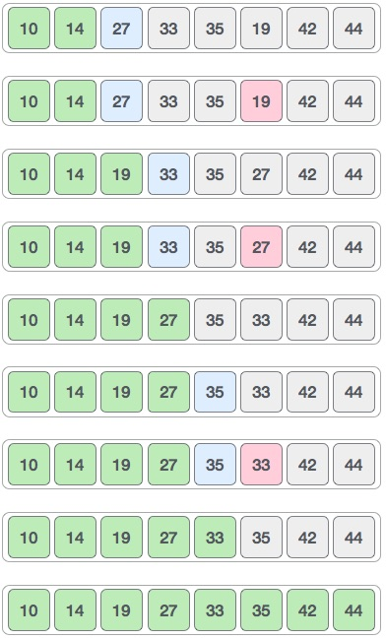

Now, let us learn some programming aspects of selection sort.

**Algorithm**

**Step 1** − Set MIN to location 0

**Step 2** − Search the minimum element in the list

**Step 3** − Swap with value at location MIN

**Step 4** − Increment MIN to point to next element

**Step 5** − Repeat until list is sorted

**Pseudocode**

procedure selection sort

list : array of items

n : size of list

for i = 1 to n - 1

/* set current element as minimum*/

min = i

/* check the element to be minimum */

for j = i+1 to n

if list[j] < list[min] then

min = j;

end if

end for

/* swap the minimum element with the current element*/

if indexMin != i then

swap list[min] and list[i]

end if

end for

end procedure

Selection sort is a simple sorting algorithm. This sorting algorithm is an in-place comparison-based algorithm in which the list is divided into two parts, the sorted part at the left end and the unsorted part at the right end. Initially, the sorted part is empty and the unsorted part is the entire list.

Implementation in C

#include <stdio.h>

#include <stdbool.h>

#define MAX 7

int intArray[MAX] = {4,6,3,2,1,9,7};

void printline(int count) {

int i;

for(i = 0;i <count-1;i++) {

printf("=");

}

printf("=\n");

}

void display() {

int i;

printf("[");

// navigate through all items

for(i = 0;i<MAX;i++) {

printf("%d ", intArray[i]);

}

printf("]\n");

}

void selectionSort() {

int indexMin,i,j;

// loop through all numbers

for(i = 0; i < MAX-1; i++) {

// set current element as minimum

indexMin = i;

// check the element to be minimum

for(j = i+1;j<MAX;j++) {

if(intArray[j] < intArray[indexMin]) {

indexMin = j;

}

}

if(indexMin != i) {

printf("Items swapped: [ %d, %d ]\n" , intArray[i], intArray[indexMin]);

// swap the numbers

int temp = intArray[indexMin];

intArray[indexMin] = intArray[i];

intArray[i] = temp;

}

printf("Iteration %d#:",(i+1));

display();

}

}

main() {

printf("Input Array: ");

display();

printline(50);

selectionSort();

printf("Output Array: ");

display();

printline(50);

}

If we compile and run the above program, it will produce the following result −

Output

Input Array: [4 6 3 2 1 9 7 ]

==================================================

Items swapped: [ 4, 1 ]

Iteration 1#:[1 6 3 2 4 9 7 ]

Items swapped: [ 6, 2 ]

Iteration 2#:[1 2 3 6 4 9 7 ]

Iteration 3#:[1 2 3 6 4 9 7 ]

Items swapped: [ 6, 4 ]

Iteration 4#:[1 2 3 4 6 9 7 ]

Iteration 5#:[1 2 3 4 6 9 7 ]

Items swapped: [ 9, 7 ]

Iteration 6#:[1 2 3 4 6 7 9 ]

Output Array: [1 2 3 4 6 7 9 ]

==================================================

**Lesson Fourteen: Merge Sort Algorithm**

Merge sort is a sorting technique based on divide and conquer technique. With worst-case time complexity being Ο(n log n), it is one of the most respected algorithms.

Merge sort first divides the array into equal halves and then combines them in a sorted manner.

**How Merge Sort Works?**

To understand merge sort, we take an unsorted array as the following −

Unsorted Array

We know that merge sort first divides the whole array iteratively into equal halves unless the atomic values are achieved. We see here that an array of 8 items is divided into two arrays of size 4.

Merge Sort Division

This does not change the sequence of appearance of items in the original. Now we divide these two arrays into halves.

Merge Sort Division

We further divide these arrays and we achieve atomic value which can no more be divided.

Merge Sort Division

Now, we combine them in exactly the same manner as they were broken down. Please note the color codes given to these lists.

We first compare the element for each list and then combine them into another list in a sorted manner. We see that 14 and 33 are in sorted positions. We compare 27 and 10 and in the target list of 2 values we put 10 first, followed by 27. We change the order of 19 and 35 whereas 42 and 44 are placed sequentially.

Merge Sort Combine

In the next iteration of the combining phase, we compare lists of two data values, and merge them into a list of found data values placing all in a sorted order.

Merge Sort Combine

After the final merging, the list should look like this −

Merge Sort

Now we should learn some programming aspects of merge sorting.

**Algorithm**

Merge sort keeps on dividing the list into equal halves until it can no more be divided. By definition, if it is only one element in the list, it is sorted. Then, merge sort combines the smaller sorted lists keeping the new list sorted too.

**Step 1** − if it is only one element in the list it is already sorted, return.

**Step 2** − divide the list recursively into two halves until it can no more be divided.

**Step 3** − merge the smaller lists into new list in sorted order.

**Pseudocode**

We shall now see the pseudocodes for merge sort functions. As our algorithms point out two main functions − divide & merge.

Merge sort works with recursion and we shall see our implementation in the same way.

procedure mergesort( var a as array )

if ( n == 1 ) return a

var l1 as array = a[0] ... a[n/2]

var l2 as array = a[n/2+1] ... a[n]

l1 = mergesort( l1 )

l2 = mergesort( l2 )

return merge( l1, l2 )

end procedure

procedure merge( var a as array, var b as array )

var c as array

while ( a and b have elements )

if ( a[0] > b[0] )

add b[0] to the end of c

remove b[0] from b

else

add a[0] to the end of c

remove a[0] from a

end if

end while

while ( a has elements )

add a[0] to the end of c

remove a[0] from a

end while

while ( b has elements )

add b[0] to the end of c

remove b[0] from b

end while

return c

end procedure

Merge sort is a sorting technique based on divide and conquer technique. With the worst-case time complexity being Ο(n log n), it is one of the most respected algorithms.

Implementation in C

We shall see the implementation of merge sort in C programming language here −

#include <stdio.h>

#define max 10

int a[11] = { 10, 14, 19, 26, 27, 31, 33, 35, 42, 44, 0 };

int b[10];

void merging(int low, int mid, int high) {

int l1, l2, i;

for(l1 = low, l2 = mid + 1, i = low; l1 <= mid && l2 <= high; i++) {

if(a[l1] <= a[l2])

b[i] = a[l1++];

else

b[i] = a[l2++];

}

while(l1 <= mid)

b[i++] = a[l1++];

while(l2 <= high)

b[i++] = a[l2++];

for(i = low; i <= high; i++)

a[i] = b[i];

}

void sort(int low, int high) {

int mid;

if(low < high) {

mid = (low + high) / 2;

sort(low, mid);

sort(mid+1, high);

merging(low, mid, high);

} else {

return;

}

}

int main() {

int i;

printf("List before sorting\n");

for(i = 0; i <= max; i++)

printf("%d ", a[i]);

sort(0, max);

printf("\nList after sorting\n");

for(i = 0; i <= max; i++)

printf("%d ", a[i]);

}

If we compile and run the above program, it will produce the following result −

Output

List before sorting

10 14 19 26 27 31 33 35 42 44 0

List after sorting

0 10 14 19 26 27 31 33 35 42 44

**Lesson Fifteen: Shell Sort**

Shell sort is a highly efficient sorting algorithm and is based on insertion sort algorithm. This algorithm avoids large shifts as in case of insertion sort, if the smaller value is to the far right and has to be moved to the far left.

This algorithm uses insertion sort on a widely spread elements, first to sort them and then sorts the less widely spaced elements. This spacing is termed as **interval**. This interval is calculated based on Knuth's formula as −

**Knuth's Formula**

h = h * 3 + 1

where −

h is interval with initial value 1

This algorithm is quite efficient for medium-sized data sets as its average and worst case complexity are of Ο(n), where **n** is the number of items.

**How Shell Sort Works?**

Let us consider the following example to have an idea of how shell sort works. We take the same array we have used in our previous examples. For our example and ease of understanding, we take the interval of 4. Make a virtual sub-list of all values located at the interval of 4 positions. Here these values are {35, 14}, {33, 19}, {42, 27} and {10, 44}

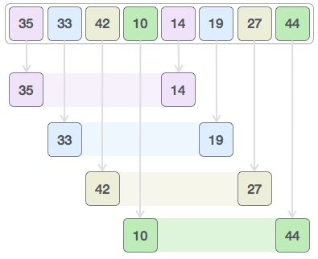

We compare values in each sub-list and swap them (if necessary) in the original array. After this step, the new array should look like this −

Shell Sort

Then, we take interval of 2 and this gap generates two sub-lists - {14, 27, 35, 42}, {19, 10, 33, 44}

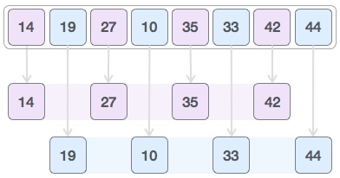

We compare and swap the values, if required, in the original array. After this step, the array should look like this −

Shell Sort

Finally, we sort the rest of the array using interval of value 1. Shell sort uses insertion sort to sort the array.

Following is the step-by-step depiction −

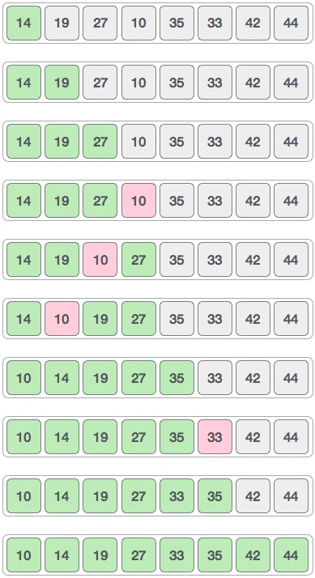

We see that it required only four swaps to sort the rest of the array.

**Algorithm**

Following is the algorithm for shell sort.

**Step 1** − Initialize the value of *h*

**Step 2** − Divide the list into smaller sub-list of equal interval *h*

**Step 3** − Sort these sub-lists using **insertion sort**

**Step 3** − Repeat until complete list is sorted

**Pseudocode**

Following is the pseudocode for shell sort.

procedure shellSort()

A : array of items

/* calculate interval*/

while interval < A.length /3 do:

interval = interval * 3 + 1

end while

while interval > 0 do:

for outer = interval; outer < A.length; outer ++ do:

/* select value to be inserted */

valueToInsert = A[outer]

inner = outer;

/*shift element towards right*/

while inner > interval -1 && A[inner - interval] >= valueToInsert do:

A[inner] = A[inner - interval]

inner = inner - interval

end while

/* insert the number at hole position */

A[inner] = valueToInsert

end for

/* calculate interval*/

interval = (interval -1) /3;

end while

end procedure

Shell sort is a highly efficient sorting algorithm and is based on insertion sort algorithm. This algorithm avoids large shifts as in case of insertion sort, if the smaller value is to the far right and has to be moved to the far left.

Implementation in C

#include <stdio.h>

#include <stdbool.h>

#define MAX 7

int intArray[MAX] = {4,6,3,2,1,9,7};

void printline(int count) {

int i;

for(i = 0;i <count-1;i++) {

printf("=");

}

printf("=\n");

}

void display() {

int i;

printf("[");

// navigate through all items

for(i = 0;i<MAX;i++) {

printf("%d ",intArray[i]);

}

printf("]\n");

}

void shellSort() {

int inner, outer;

int valueToInsert;

int interval = 1;

int elements = MAX;

int i = 0;

while(interval <= elements/3) {

interval = interval*3 +1;

}

while(interval > 0) {

printf("iteration %d#:",i);

display();

for(outer = interval; outer < elements; outer++) {

valueToInsert = intArray[outer];

inner = outer;

while(inner > interval -1 && intArray[inner - interval]

>= valueToInsert) {

intArray[inner] = intArray[inner - interval];

inner -=interval;

printf(" item moved :%d\n",intArray[inner]);

}

intArray[inner] = valueToInsert;

printf(" item inserted :%d, at position :%d\n",valueToInsert,inner);

}

interval = (interval -1) /3;

i++;

}

}

int main() {

printf("Input Array: ");

display();

printline(50);

shellSort();

printf("Output Array: ");

display();

printline(50);

return 1;

}

If we compile and run the above program, it will produce the following result −

Output

Input Array: [4 6 3 2 1 9 7 ]

==================================================

iteration 0#:[4 6 3 2 1 9 7 ]

item moved :4

item inserted :1, at position :0

item inserted :9, at position :5

item inserted :7, at position :6

iteration 1#:[1 6 3 2 4 9 7 ]

item inserted :6, at position :1

item moved :6

item inserted :3, at position :1

item moved :6

item moved :3

item inserted :2, at position :1

item moved :6

item inserted :4, at position :3

item inserted :9, at position :5

item moved :9

item inserted :7, at position :5

Output Array: [1 2 3 4 6 7 9 ]

==================================================

**Lesson Sixteen: Quick Sort**

Quick sort is a highly efficient sorting algorithm and is based on partitioning of array of data into smaller arrays. A large array is partitioned into two arrays one of which holds values smaller than the specified value, say pivot, based on which the partition is made and another array holds values greater than the pivot value.

Quick sort partitions an array and then calls itself recursively twice to sort the two resulting subarrays. This algorithm is quite efficient for large-sized data sets as its average and worst case complexity are of Ο(nlogn), where **n** is the number of items.

**Partition in Quick Sort**

Following animated representation explains how to find the pivot value in an array.



The pivot value divides the list into two parts. And recursively, we find the pivot for each sub-lists until all lists contains only one element.

**Quick Sort Pivot Algorithm**

Based on our understanding of partitioning in quick sort, we will now try to write an algorithm for it, which is as follows.

**Step 1** − Choose the highest index value has pivot

**Step 2** − Take two variables to point left and right of the list excluding pivot

**Step 3** − left points to the low index

**Step 4** − right points to the high

**Step 5** − while value at left is less than pivot move right

**Step 6** − while value at right is greater than pivot move left

**Step 7** − if both step 5 and step 6 does not match swap left and right

**Step 8** − if left ≥ right, the point where they met is new pivot

**Quick Sort Pivot Pseudocode**

The pseudocode for the above algorithm can be derived as −

function partitionFunc(left, right, pivot)

leftPointer = left

rightPointer = right - 1

while True do

while A[++leftPointer] < pivot do

//do-nothing

end while

while rightPointer > 0 && A[--rightPointer] > pivot do

//do-nothing

end while

if leftPointer >= rightPointer

break

else

swap leftPointer,rightPointer

end if

end while

swap leftPointer,right

return leftPointer

end function

**Quick Sort Algorithm**

Using pivot algorithm recursively, we end up with smaller possible partitions. Each partition is then processed for quick sort. We define recursive algorithm for quicksort as follows −

**Step 1** − Make the right-most index value pivot

**Step 2** − partition the array using pivot value

**Step 3** − quicksort left partition recursively

**Step 4** − quicksort right partition recursively

**Quick Sort Pseudocode**

To get more into it, let see the pseudocode for quick sort algorithm −

procedure quickSort(left, right)

if right-left <= 0

return

else

pivot = A[right]

partition = partitionFunc(left, right, pivot)

quickSort(left,partition-1)

quickSort(partition+1,right)

end if

end procedure

Quick sort is a highly efficient sorting algorithm and is based on partitioning of array of data into smaller arrays. A large array is partitioned into two arrays one of which holds values smaller than the specified value, say pivot, based on which the partition is made and another array holds values greater than the pivot value.

Implementation in C

#include <stdio.h>

#include <stdbool.h>

#define MAX 7

int intArray[MAX] = {4,6,3,2,1,9,7};

void printline(int count) {

int i;

for(i = 0;i <count-1;i++) {

printf("=");

}

printf("=\n");

}

void display() {

int i;

printf("[");

// navigate through all items

for(i = 0;i<MAX;i++) {

printf("%d ",intArray[i]);

}

printf("]\n");

}

void swap(int num1, int num2) {

int temp = intArray[num1];

intArray[num1] = intArray[num2];

intArray[num2] = temp;

}

int partition(int left, int right, int pivot) {

int leftPointer = left -1;

int rightPointer = right;

while(true) {

while(intArray[++leftPointer] < pivot) {

//do nothing

}

while(rightPointer > 0 && intArray[--rightPointer] > pivot) {

//do nothing

}

if(leftPointer >= rightPointer) {

break;

} else {

printf(" item swapped :%d,%d\n", intArray[leftPointer],intArray[rightPointer]);

swap(leftPointer,rightPointer);

}

}

printf(" pivot swapped :%d,%d\n", intArray[leftPointer],intArray[right]);

swap(leftPointer,right);

printf("Updated Array: ");

display();

return leftPointer;

}

void quickSort(int left, int right) {

if(right-left <= 0) {

return;

} else {

int pivot = intArray[right];

int partitionPoint = partition(left, right, pivot);

quickSort(left,partitionPoint-1);

quickSort(partitionPoint+1,right);

}

}

main() {

printf("Input Array: ");

display();

printline(50);

quickSort(0,MAX-1);

printf("Output Array: ");

display();

printline(50);

}

If we compile and run the above program, it will produce the following result −

Output

Input Array: [4 6 3 2 1 9 7 ]

==================================================

pivot swapped :9,7

Updated Array: [4 6 3 2 1 7 9 ]

pivot swapped :4,1

Updated Array: [1 6 3 2 4 7 9 ]

item swapped :6,2

pivot swapped :6,4

Updated Array: [1 2 3 4 6 7 9 ]

pivot swapped :3,3

Updated Array: [1 2 3 4 6 7 9 ]

Output Array: [1 2 3 4 6 7 9 ]

==================================================